DESIGN AND IMPLEMENTATION OF A SECURE DIASPORA E-VOTING PROTOTYPE USING zk-STARK PROTOCOLS

BY

ADELUKA OLUWAMBEPELUMI EMMANUEL
(22CG0XXXX)
A PROJECT SUBMITTED TO THE DEPARTMENT OF COMPUTER AND INFORMATION SCIENCES, COLLEGE OF SCIENCE AND TECHNOLOGY, COVENANT UNIVERSITY, OTA, OGUN STATE.
IN PARTIAL FULFILMENT OF THE REQUIREMENTS FOR THE AWARD OF THE BACHELOR OF SCIENCE (HONOURS) DEGREE IN COMPUTER SCIENCE.

JUNE, 2026

CERTIFICATION
I hereby certify that this project was carried out by Adeluka Oluwambepelumi Emmanuel in the Department of Computer and Information Sciences, College of Science and Technology, Covenant University, Ota, Ogun State, Nigeria, under appropriate academic supervision.

______________________________
Project Supervisor

______________________________
Head of Department

DEDICATION
This work is dedicated to God Almighty, whose grace sustained the entire study, and to my family for their encouragement, sacrifices, and unwavering support throughout the programme.

ACKNOWLEDGEMENTS
My sincere gratitude goes to God for His grace, strength, and guidance throughout the course of this project. I am also grateful to my family and loved ones for their patience, encouragement, and support during the research, implementation, and documentation stages of this work.
I further appreciate the academic guidance, technical feedback, and institutional support received from the Department of Computer and Information Sciences, Covenant University. The comments and reviews provided during the development of the DiasporaVote prototype contributed significantly to the clarity, scope control, and final presentation of this study.

TABLE OF CONTENT

LIST OF FIGURES
Figure 3.1 Use-case diagram for DiasporaVote actors
Figure 3.2 DiasporaVote system architecture
Figure 3.3 Voting workflow for the controlled referendum prototype
Figure 3.4 zk-STARK proof verification flow
Figure 3.5 Database and entity-relationship design
Figure 4.1 Landing page of the DiasporaVote prototype
Figure 4.2 Mock NIN accreditation page
Figure 4.3 Camera-based prototype verification page
Figure 4.4 Event dashboard showing the active referendum
Figure 4.5 Active referendum ballot page
Figure 4.6 Vote review page
Figure 4.7 Receipt page showing the Ballot ID and Proof Hash
Figure 4.8 Public verification board
Figure 4.9 Proof verification result
Figure 4.10 Tally dashboard
Figure 4.11 Admin login page
Figure 4.12 Admin mock voter registry page
Figure 4.13 Admin create-voter confirmation page

LIST OF TABLES
Table 1.1 Objectives-Methodology Mapping Table
Table 3.1 Functional Requirements of the System
Table 3.2 Non-Functional Requirements of the System
Table 3.3 Threat Model and Mitigation Strategy
Table 3.4 Voter Table Design
Table 3.5 Event Table Design
Table 3.6 Ballot Table Design
Table 3.7 Public and Private Verification Data
Table 4.1 Hardware Requirements
Table 4.2 Software Requirements
Table 4.3 Evaluation Criteria
Table 4.4 Functional Evaluation Results
Table 4.5 Comparative Benchmark Against Existing Systems
Table 4.6 Program Interfaces

ABBREVIATIONS
API Application Programming Interface
BVAS Bimodal Voter Accreditation System
CIS Computer and Information Sciences
CSS Cascading Style Sheets
FYP Final Year Project
HTML HyperText Markup Language
INEC Independent National Electoral Commission
NIMC National Identity Management Commission
NIN National Identification Number
RAM Random Access Memory
SQL Structured Query Language
STARK Scalable Transparent Argument of Knowledge
UI User Interface
URL Uniform Resource Locator
ZKP Zero-Knowledge Proof

ABSTRACT
This study addressed the challenge of how secure diaspora voting could be demonstrated in a controlled Nigerian context without overclaiming institutional integration or national-election readiness. The project designed and implemented DiasporaVote, a secure binary referendum prototype that combined a React frontend, a Flask backend, SQLite persistence, a mock National Identification Number registry, and a Winterfell-based zk-STARK proof engine. The implemented workflow covered mock voter accreditation, camera-based prototype verification, event-aware ballot access, controlled Yes/No vote submission, proof generation and verification, encrypted ballot storage, receipt issuance, public-board publication of privacy-preserving verification metadata, and tally display for the active referendum event. System evaluation included registered-voter login, rejection of unregistered users, verification-state enforcement, valid and invalid ballot handling, duplicate-vote rejection, proof verification, tally behaviour, admin registry operations, and persistence checks. The results showed that the controlled binary referendum workflow was feasible within the scope of the prototype. The main contribution of the study was the implementation of a technically defensible diaspora voting prototype that demonstrated proof-backed ballot acceptance and server-mediated public verification while clearly stating its limitations, including mock identity assurance, binary-ballot scope, and non-production deployment status.
Keywords: diaspora voting, e-voting, zk-STARK, zero-knowledge proof, public verification, referendum prototype

CHAPTER ONE: INTRODUCTION

1.1 Background Information
Citizen participation is a key signal of political inclusion, national legitimacy, and public trust in democracy. In Nigeria, this issue is becoming even more significant because a large number of Nigerians live abroad while still maintaining strong economic, social, and political ties to the country. Through remittances, investment, professional expertise, advocacy, and other forms of transnational engagement, the Nigerian diaspora plays a visible role in national development. Yet, when it comes to elections, meaningful participation is still largely tied to being physically present in Nigeria. Since the exact size of the Nigerian diaspora is often discussed using different estimates, this study avoids relying on an unverified figure and instead recognises that Nigerians abroad are widely understood to be in the millions. This creates a strong motivation to explore technical models that could support secure and verifiable diaspora voting if the legal and institutional framework becomes available.
At present, Nigeria’s electoral process is still built around physical registration and physical voting. The cycle typically involves voter registration, polling-unit accreditation, paper ballots, manual counting, result recording, and collation. The Electoral Act, 2022 states that a person qualifies to register as a voter if the person is a Nigerian citizen, is at least 18 years old, is ordinarily resident in, works in, or originates from the relevant Local Government Area, Area Council, or Ward, presents himself or herself for registration, and is not legally disqualified from voting (Federal Republic of Nigeria, 2022). The Act also recognises technology at the polling unit by providing for accreditation using a voter’s card and a smart card reader or another device prescribed by the Commission (Federal Republic of Nigeria, 2022). These provisions show that technology already has a place in Nigerian elections, but they do not yet create a complete path for remote voting by citizens who are outside the country. Any serious diaspora voting model would therefore have to satisfy both sides of the problem: the legal requirement for electoral control and the technical requirement for secure remote participation.
Once voting becomes remote, new risks appear, especially risks that are naturally constrained in a physical polling unit. In-person elections rely on visible checks such as officials, party agents, security personnel, observers, ballot boxes, and counting procedures that people can witness. In a diaspora scenario, the voter is not physically present at a polling unit, so the system must provide a digital substitute for accreditation, ballot privacy, prevention of repeat voting, and overall public confidence. A simple online portal where a user logs in, clicks a choice, and receives a “vote submitted” message is not enough. Without stronger safeguards, it raises obvious concerns about impersonation, duplicate voting, privacy leakage, server-side manipulation, and result tampering. In other words, secure diaspora e-voting is not just a user interface problem; it is a trust architecture problem. The system must be able to show that accepted ballots followed defined rules, not merely that the server claims they did.
Research in electronic voting has consistently pointed to the same balancing act: public confidence requires both privacy and verifiability. Verifiable online voting systems aim to give voters and observers credible evidence that ballots were recorded and counted correctly, while still keeping each voter’s choice private (Alsadi et al., 2019). The goal is to reduce the need for blind trust. Voters should not have to rely solely on the assumption that the server behaved honestly, and observers should not need access to private votes before they can confirm that procedures were followed. To support this, many systems rely on cryptographic tools such as encryption, hashing, digital commitments, public bulletin boards, and zero-knowledge proofs. These tools are useful because they enable meaningful checking and auditing without turning the election record into a public exposure of voter identities or ballot choices.
Zero-knowledge proofs are especially relevant here because they allow a party to prove that something is true without revealing the private information behind it. The foundational idea was introduced through work on interactive proof systems by Goldwasser, Micali, and Rackoff, and it has since become a major building block for privacy-preserving cryptographic systems (Goldwasser et al., 1989). In voting, that property matters because an election system often needs to show that a ballot meets certain validity rules without revealing who cast the ballot or what option they selected. For example, a ballot can be proven valid under the rules while keeping sensitive voter information away from the public verification layer. This makes zero-knowledge proofs a strong fit for a diaspora voting prototype where the public needs evidence that the process is working, but should not see private voting details.
This project focuses specifically on zk-STARKs, where zk-STARK means Zero-Knowledge Scalable Transparent Argument of Knowledge. zk-STARKs are particularly attractive in public-interest settings because they support proof generation and verification without relying on a trusted setup, an assumption that can be difficult to justify in sensitive national systems (Ben-Sasson et al., 2018). In practical terms, zk-STARKs allow a system to generate a proof that a computation followed defined rules, and then allow that proof to be verified. In this project, the computation is not a full national election. Instead, it is a controlled ballot validity workflow for a binary diaspora referendum. That choice keeps the constraint system focused, testable, and achievable within the scope of a final year technical implementation.
The project therefore implements a secure diaspora e-voting prototype using a binary referendum ballot as a controlled scenario. The referendum asks whether secure diaspora voting should be enabled for eligible Nigerians abroad, and the voter chooses either Yes or No. This format was selected deliberately: it keeps the cryptographic validity rules manageable while still demonstrating the security properties that matter in remote voting. The prototype covers mock voter accreditation, duplicate-vote prevention, proof-backed ballot acceptance, encrypted ballot storage, public receipt verification, and event-aware tallying. It is not presented as a full INEC replacement or a simulation of a presidential election. Rather, it is a working technical prototype that explores how cryptographic verification can strengthen trust in a remote diaspora voting workflow.

1.2 Statement of the Problem
Despite the growing relevance of the Nigerian diaspora to national development, eligible Nigerians abroad do not currently have a practical remote voting mechanism for participating in Nigerian elections. Nigeria’s electoral procedures are still designed around local registration, physical attendance, polling-unit accreditation, and voting at assigned polling units, which makes participation difficult for citizens living outside the country (Federal Republic of Nigeria, 2022). Although technology is already used in voter accreditation, the current structure does not provide an end-to-end digital voting process that supports diaspora participation securely. This creates a clear gap between the desire for diaspora political inclusion and the technical systems required to make that inclusion credible. The problem is not simply the lack of an online portal; it is the lack of a trust model that can support eligibility checking, one-person-one-vote enforcement, ballot privacy, public verification, and reliable tallying in a remote environment.
A basic online voting system that relies only on backend logic and user interface confirmation introduces serious risks. A voter may be told that a ballot has been submitted, but without a verifiable receipt or proof-linked public record, the voter cannot confidently know that the ballot was accepted and counted. In the same way, observers may have no reliable way to detect whether the server accepted fake ballots, rejected valid ones, altered ballot records, or selectively counted votes. Research on verifiable online voting highlights that this lack of transparency and verifiability is a major barrier to large-scale adoption of online elections (Alsadi et al., 2019). For this reason, the project addresses the need for a secure diaspora e-voting prototype that combines mock eligibility checks, duplicate-vote prevention, encrypted ballot storage, zk-STARK proof generation and verification, public receipt checking, and event-aware tallying within a controlled Nigerian diaspora referendum scenario.

1.3 Aim and Objectives of the Study
The aim of this study is to design and implement a secure diaspora e-voting prototype for the Nigerian context using zk-STARK protocols. The study is guided by the following objectives:
1. To review existing e-voting systems and the cryptographic approaches they use.
2. To analyse the security requirements and threat model for diaspora e-voting.
3. To design a zk-STARK-based ballot validity constraint system.
4. To implement a working prototype integrating zk-STARK proof generation, encrypted ballot submission, and public verification.
5. To evaluate the prototype’s performance and security properties.

1.4 Methodology
This project followed a technical implementation approach that combined literature review, system analysis, cryptographic design, software development, deployment, and prototype evaluation. The methodology was arranged to follow the objectives of the study so that each objective had a corresponding implementation or evaluation activity. The literature review established the background for e-voting, diaspora voting, zero-knowledge proofs, and existing verifiable voting systems. The design and implementation stages then translated the identified security requirements into a working prototype using React, Flask, SQLite, a mock NIN identity layer, and a Winterfell-based zk-STARK proof engine. Table 1.1 shows the mapping of each objective to the methodology used in the project.
Table 1.1: Objectives-Methodology Mapping Table
S/N | Objectives | Methodology
1 | To review existing e-voting systems and the cryptographic approaches they use. | i. Relevant literature on electronic voting, verifiable voting, public bulletin boards, ballot secrecy, and zero-knowledge proofs was reviewed. ii. Existing systems such as Helios and Belenios were studied to understand how verifiability, encryption, and public auditability are used in online voting systems. iii. The review identified gaps relating to diaspora voting, server trust, privacy-preserving verification, and the use of zk-STARK protocols in a Nigerian voting context.
2 | To analyse the security requirements and threat model for diaspora e-voting. | i. The remote voting workflow was analysed to identify security requirements such as eligibility, privacy, soundness, verifiability, duplicate-vote prevention, and tally correctness. ii. Threats such as impersonation, duplicate voting, ballot manipulation, server-side trust abuse, public privacy leakage, and tally manipulation were identified. iii. Mitigation strategies were mapped to system components, including mock NIN accreditation, session control, encrypted storage, proof verification, public receipt metadata, and event-aware tallying.
3 | To design a zk-STARK-based ballot validity constraint system. | i. A binary referendum ballot format was selected to keep the constraint system focused and testable. ii. The ballot validity rules were defined around accepted vote values, voter eligibility, duplicate-vote prevention, and proof-backed acceptance. iii. A Winterfell-based proof engine was used to generate and verify proof artifacts connected to accepted ballot records. iv. Proof hashes were used to link public ballot receipts to the proof artifacts used during acceptance.
4 | To implement a working prototype integrating zk-STARK proof generation, encrypted ballot submission, and public verification. | i. The frontend was implemented with React to support voter accreditation, camera-based prototype verification, event selection, ballot casting, receipt display, public board viewing, tally viewing, and admin registry management. ii. The backend was implemented with Flask to manage registration, login, biometric verification, voting, proof verification, public board records, tallying, and admin operations. iii. SQLite was used for persistent registry, ballot, event, and receipt storage. iv. The backend integrated the Winterfell proof engine so that proof generation and verification occurred before ballot storage.
5 | To evaluate the prototype’s performance and security properties. | i. Functional testing was carried out to confirm voter accreditation, ballot submission, duplicate-vote rejection, proof verification, public board display, and tally update. ii. Deployment testing was conducted using Railway for the backend, Vercel for the frontend, and Railway volume storage for persistence. iii. Performance evaluation was planned around proof generation time, proof verification time, and proof size across benchmark runs. iv. Security analysis was conducted by examining how the prototype addressed eligibility, privacy-preserving public metadata, tamper-evidence, duplicate-vote prevention, and server-mediated public verification.

1.5 Significance of the Study
This study is significant because it contributes to the discussion of secure digital voting from both a Nigerian electoral context and a cryptographic system implementation perspective. It does not claim to solve all legal and institutional issues surrounding diaspora voting, but it demonstrates how a technical prototype can model some of the security properties that would be required in such a system. The significance of the study is listed below:
The study contributes to Nigerian electoral technology discourse by showing how diaspora voting can be examined as a secure technical workflow rather than only as a policy proposal.
The study provides a prototype blueprint for how eligibility checking, one-person-one-vote enforcement, proof-backed ballot acceptance, and public receipt verification can be combined in a remote voting environment.
The study demonstrates the use of zk-STARK proof generation and verification in an African civic technology context, thereby extending the application of zero-knowledge proof systems beyond blockchain-centred discussions.
The study supports academic understanding of privacy-preserving public verification by showing how public ballot metadata can be published without exposing voter identity, full NIN, NIN hash, raw vote, decrypted vote, session token, or private proof path.
The study provides a foundation for future work on more advanced diaspora voting systems that could include stronger identity assurance, independently verifiable proof tooling, larger election formats, and formal institutional integration.

1.6 Scope of the Study
This study focused on the design and implementation of a secure diaspora e-voting prototype using zk-STARK protocols. The prototype was limited to a controlled binary referendum ballot in which an eligible mock diaspora voter could vote either Yes or No on the referendum question. The binary ballot was intentional because it allowed the cryptographic constraint system to remain focused and testable while still demonstrating important voting-system properties. The system covered mock voter registry management, mock NIN accreditation, camera-based prototype verification, event selection, ballot casting, duplicate-vote prevention, proof generation, proof verification, encrypted ballot storage, public receipt publication, and event-aware tallying. The implementation used React for the frontend, Flask for the backend, SQLite for persistent storage, and a Winterfell-based zk-STARK proof engine for proof generation and verification.
The identity layer in this study was simulated using a mock NIN registry and did not connect to a live National Identity Management Commission database. The system did not connect to live Independent National Electoral Commission infrastructure and did not implement BVAS, real facial recognition, national voter registration, political party management, candidate management, state collation, polling-unit administration, or presidential election simulation. The camera-based verification step was treated as a prototype presence-checking ceremony and not as certified biometric identity matching. Public verification in the prototype was server-mediated, meaning the user requested the backend to verify the stored proof rather than independently verifying the proof locally on the user’s device. The evaluation focused on the correctness of the implemented prototype workflow, proof generation and verification behaviour, public receipt privacy, duplicate-vote rejection, tally correctness, deployment readiness, and benchmark-related performance properties.

1.7 Project Outline
This project is organized into five chapters. Chapter One introduces the study by presenting the background information, statement of the problem, aim and objectives, methodology, significance of the study, scope of the study, and project outline. Chapter Two reviews relevant literature on electronic voting systems, diaspora voting, zero-knowledge proofs, zk-SNARKs, zk-STARKs, cryptographic hashing, ballot privacy, public verifiability, related works, and existing systems such as Helios and Belenios. Chapter Three presents the system analysis and design, including requirement analysis, system architecture, threat model, voting protocol design, zk-STARK constraint system design, and database design. Chapter Four describes the system implementation, implementation tools, development methodology, system evaluation, benchmarking, security analysis, discussion, and program modules and interfaces. Chapter Five presents the summary of the project, recommendations for future work, limitations of the study, and conclusion.

CHAPTER TWO: LITERATURE REVIEW

2.1 Preamble
This chapter reviews literature relevant to the design and implementation of a secure diaspora e-voting prototype using zk-STARK protocols. The review begins with electronic voting systems because the project is situated within the broader field of digital electoral technology. It then examines diaspora voting as a policy and participation issue, especially because the system developed in this study focuses on citizens who are outside the country during an election. The chapter also reviews relevant cryptographic concepts, including zero-knowledge proofs, zk-SNARKs, zk-STARKs, hashing, commitments, ballot privacy, and public verifiability. These concepts provide the theoretical foundation for understanding why the prototype combines voter accreditation, duplicate-vote prevention, encrypted ballot storage, proof-backed ballot acceptance, public receipt checking, and tallying. The later sections of the chapter review related works and existing systems in order to identify the gap addressed by the implemented prototype.

2.2 Review of Electronic Voting Systems
Electronic voting refers to the use of electronic technologies to support, automate, or manage one or more stages of the voting process. Depending on the design, electronic voting may involve electronic voter authentication, ballot marking devices, direct-recording electronic machines, optical-scan systems, internet voting, electronic tallying, or public result transmission. The main attraction of electronic voting is that it can improve speed, accessibility, ballot handling, and result processing when implemented under proper institutional and security controls. However, electronic voting also introduces risks that are not always present in paper-based systems, including software errors, malware, network attacks, insider manipulation, server compromise, privacy leakage, and loss of public confidence. For this reason, electronic voting systems are usually assessed using security properties such as accuracy, privacy, eligibility, verifiability, auditability, availability, usability, and resistance to tampering (Ali & Murray, 2016).
A major distinction in electronic voting literature is the difference between supervised and remote voting. Supervised electronic voting usually occurs in a controlled polling environment where election officials, observers, and physical procedures still provide part of the trust framework. Remote electronic voting, on the other hand, allows voters to cast ballots from locations outside a polling station, often through the internet or another communication channel. Remote voting is attractive for diaspora voters because it can reduce geographical barriers and allow participation from outside the country. However, it also makes the system more difficult to secure because the voter’s device, network environment, identity process, and voting privacy are harder to control. These concerns explain why a remote diaspora voting model requires more than a normal website; it needs a security design that addresses eligibility, ballot secrecy, duplicate-vote prevention, verifiable acceptance, and trustworthy tallying (Alsadi et al., 2019).
Traditional paper elections provide several visible trust mechanisms that remote voting systems must replace or supplement digitally. In a physical election, a voter is usually accredited in person, receives a ballot, marks the ballot privately, places it in a ballot box, and the ballot is later counted under the observation of election officials and agents. These procedures do not remove all risks, but they allow people to observe and challenge parts of the process. In remote online voting, many of these trust signals disappear because the voter is not physically present and the ballot is processed by software systems that ordinary users cannot directly inspect. This creates a “black box” concern where voters may see a confirmation message without knowing whether the system stored, protected, or counted the ballot correctly. End-to-end verifiable voting research attempts to address this issue by giving voters and observers mathematical evidence that ballots were properly recorded and included in the tally without exposing private choices (Quaglia & Smyth, 2017).
End-to-end verifiable voting systems aim to provide assurance across the full voting chain, from ballot casting to final tally. A common way to describe this is through properties such as cast-as-intended, recorded-as-cast, and tallied-as-recorded. Cast-as-intended means the ballot reflects the voter’s actual choice, recorded-as-cast means the submitted ballot appears correctly in the election record, and tallied-as-recorded means the final tally is derived from the accepted ballots. These properties are important because they reduce dependence on blind trust in the election authority or software provider. In many systems, this is supported through cryptographic tools such as encrypted ballots, public bulletin boards, mixnets, homomorphic tallying, digital signatures, hashes, or zero-knowledge proofs. While the implemented prototype in this study does not claim to deliver a full production-grade end-to-end voting protocol, it adopts the same general motivation by using public receipts and proof verification to strengthen trust in ballot acceptance (Ali & Murray, 2016).
Security and usability remain major tensions in electronic voting systems. A system that is too complex may be difficult for voters to use correctly, while a system that is too simple may hide important security weaknesses. For example, a voter-facing receipt must allow ballot inclusion checking without becoming a vote-buying receipt that proves how the voter voted to another person. Similarly, a public board must support auditability without exposing voter identity, raw vote choice, or sensitive credentials. These trade-offs are especially important in diaspora voting because the system must serve users in different locations, devices, and network conditions. Therefore, this project adopted a controlled binary referendum ballot to keep the security workflow focused while still demonstrating important electronic voting properties such as accreditation, duplicate-vote prevention, encrypted storage, proof-backed acceptance, public receipt checking, and tallying.

2.3 Review of Diaspora Voting — Context and Policy
Diaspora voting, also known as external voting or voting from abroad, refers to arrangements that allow citizens outside their country to participate in elections or referenda. Countries use different models for external voting, including embassy voting, postal voting, proxy voting, internet voting, and special overseas constituencies. The policy argument for diaspora voting is usually based on citizenship, political inclusion, remittance contribution, national identity, and continued attachment to the home country. However, the implementation of diaspora voting differs widely because countries must decide who qualifies, how registration will work, what elections overseas citizens can vote in, how ballots will be transmitted, and how fraud or coercion will be prevented. This makes diaspora voting both a political issue and a technical systems issue, especially when remote electronic voting is considered (International IDEA, 2007).
In the Nigerian context, diaspora voting is important because many Nigerians live abroad while maintaining strong economic, family, social, and political links with Nigeria. These links make political participation a reasonable subject of discussion, especially where citizens abroad remain affected by government policy and national development outcomes. However, Nigeria’s current electoral framework is still structured around local registration, physical accreditation, and voting at assigned polling units. The Electoral Act, 2022 defines voter registration around citizenship, age, residence, work, origin, personal presentation for registration, and legal qualification, while accreditation is tied to polling-unit procedures and technologies prescribed by the Independent National Electoral Commission (Federal Republic of Nigeria, 2022). This means that diaspora voting is not merely a matter of creating a web application; it requires legal, institutional, identity, security, and trust arrangements.
A secure diaspora voting model must solve problems that are partly different from those in domestic polling-unit elections. In domestic elections, electoral staff and observers can physically supervise voter queues, ballot papers, ballot boxes, and counting activities. In diaspora voting, the voter may be in another country, using a personal device, a private network, and a remote authentication process. This creates risks of impersonation, credential theft, malware interference, duplicate voting, coercion, vote selling, and public distrust in the backend server. A technical system must therefore support eligibility checking, one-person-one-vote enforcement, ballot secrecy, public auditability, and tamper-evident records. The implemented prototype models these requirements through a mock NIN registry, camera-based prototype verification, ballot validity rules, zk-STARK proof verification, encrypted ballot storage, and public receipt metadata.
The policy sensitivity of diaspora voting also means that a prototype must not overstate its role. A student project cannot create the legal basis for diaspora voting, connect to live national identity infrastructure, or replace the electoral commission. What it can do is demonstrate a controlled technical model for how some security requirements could be implemented if a legal and institutional framework becomes available. This distinction is important because diaspora voting requires both electoral legitimacy and technical credibility. The system developed in this study therefore uses a mock identity layer and a binary referendum to avoid pretending to be a live national election system. Its value lies in demonstrating how a remote voting workflow can combine accreditation, duplicate prevention, proof-backed acceptance, privacy-preserving public receipts, and tallying in a testable academic prototype.

2.4 Review of Relevant Concepts
This section reviews the major concepts needed to understand the implemented prototype. The concepts are not reviewed as isolated theory but as ideas that directly support the design decisions in the system. Zero-knowledge proofs explain how validity can be proven without exposing sensitive details. The comparison between zk-SNARKs and zk-STARKs explains why zk-STARKs are relevant to a public verification setting. Hashing and commitments explain why proof hashes and public receipt records are useful. Ballot privacy and public verifiability explain the central tension that the system tries to balance. Together, these concepts form the cryptographic foundation for the prototype.

2.4.1 Zero-Knowledge Proofs
A zero-knowledge proof is a cryptographic method that allows one party, called the prover, to convince another party, called the verifier, that a statement is true without revealing the private information used to prove it. The foundational work on zero-knowledge proofs came from the study of interactive proof systems by Goldwasser, Micali, and Rackoff. Their work introduced the idea that a proof can convince a verifier while releasing no additional knowledge beyond the validity of the statement being proven (Goldwasser et al., 1989). In simple terms, zero-knowledge proofs separate the truth of a claim from the private data behind the claim. This is valuable in systems where correctness must be checked but sensitive information should not be exposed. Voting is one of the fields where this idea is especially important because ballot validity and voter eligibility need to be checked without making the voter’s private choice public.
Zero-knowledge proofs are usually discussed using three broad properties: completeness, soundness, and zero-knowledge. Completeness means that if the statement is true and the prover follows the protocol correctly, the verifier should accept the proof. Soundness means that if the statement is false, a dishonest prover should not be able to convince the verifier except with very small probability. Zero-knowledge means that the verifier learns nothing beyond the fact that the statement is true. In a voting system, these properties can help ensure that valid ballots are accepted, invalid ballots are rejected, and private voting information is not unnecessarily revealed. Although real-world voting systems require many additional controls, these three properties explain why zero-knowledge proofs are useful in privacy-preserving election technology.
In the context of this project, zero-knowledge proof concepts are used to support proof-backed ballot acceptance. The prototype does not merely store a vote because a voter clicks a button on the frontend. Instead, the backend invokes a proof engine, verifies the generated proof, and only then stores the encrypted ballot record. This gives the system a stronger acceptance process than a simple poll application because accepted ballots are tied to proof artifacts and public proof hashes. The public dashboard does not expose the voter’s name, full NIN, NIN hash, raw vote, decrypted vote, session token, or private proof path. Therefore, the proof system supports the project’s privacy-preserving public verification metadata, while the implementation remains honest that public verification is server-mediated in the current prototype.

2.4.2 zk-SNARKs and zk-STARKs
Zero-knowledge proof systems have different families, and two of the most widely discussed families are zk-SNARKs and zk-STARKs. zk-SNARK means Zero-Knowledge Succinct Non-Interactive Argument of Knowledge, while zk-STARK means Zero-Knowledge Scalable Transparent Argument of Knowledge. Both are designed to allow verification of a computation without revealing private inputs, but they differ in their setup assumptions, proof characteristics, verification models, and cryptographic foundations. zk-SNARKs are known for compact proof sizes and efficient verification, which makes them attractive in many blockchain and privacy applications. However, many zk-SNARK constructions historically relied on a trusted setup, meaning that a setup ceremony had to be performed honestly for the system to remain secure.
zk-STARKs are important because they were designed to provide scalable and transparent computational integrity. Transparency means that the system does not require the same kind of secret trusted setup associated with several earlier zk-SNARK designs. This property is significant in public-interest systems because citizens and observers may be uncomfortable with hidden setup assumptions that are difficult to verify. zk-STARKs are also commonly discussed as post-quantum-oriented because their security is based on hash functions and information-theoretic techniques rather than elliptic-curve pairings, although any practical implementation still depends on correct engineering and parameter choices (Ben-Sasson et al., 2018). For this project, the transparency and verification orientation of zk-STARKs make them suitable for demonstrating proof-backed ballot acceptance in a diaspora e-voting prototype.
In practical terms, zk-STARKs allow a computation to be transformed into a proof that can later be checked by a verifier. In this study, the relevant computation is not a broad national election computation but a controlled ballot validity workflow for a binary referendum. The binary referendum format was selected because it keeps the constraint system focused and testable. The main validity rules revolve around accepting a vote value in the allowed ballot range, checking that the voter has passed the eligibility workflow, preventing duplicate voting, and linking the accepted ballot to a proof record. This design does not claim to solve every problem in real-world national elections, but it demonstrates how zk-STARK proof generation and verification can be introduced into a remote voting workflow.

2.4.3 Cryptographic Hashing and Commitments
A cryptographic hash function maps input data of any length into a fixed-length output called a hash value or digest. A secure hash function is expected to be one-way, meaning that it should be computationally difficult to reconstruct the original input from the hash output. It should also be collision-resistant, meaning that it should be difficult to find two different inputs that produce the same hash. These properties make hashing useful in digital systems where data integrity must be checked without exposing or storing the original data in public form. In voting systems, hashes can be used to link records, protect sensitive identifiers, fingerprint proof artifacts, and detect changes to published data.
In this project, hashing is important because the public verification board displays proof hashes rather than exposing private proof paths or sensitive internal data. The proof hash acts like a fingerprint of the proof artifact attached to an accepted ballot. If the proof artifact changes, it should no longer match the published hash. This allows the public record to link a ballot receipt to the proof used during acceptance without placing sensitive backend files directly into the public interface. The voter-facing Ballot ID helps the voter find the ballot receipt, while the Proof Hash supports auditability by linking the record to the proof artifact. This is why the proof hash is not mainly a normal voter convenience feature; it is an integrity and audit feature.
Commitments are also important in cryptographic voting because they allow a value to be fixed at one point in time while hiding it until a later stage. A commitment scheme is often described as having two properties: hiding and binding. Hiding means the committed value is not revealed from the commitment itself, while binding means the committer cannot easily change the value after committing to it. In electronic voting, commitment ideas are useful because a system may need to bind a voter or server to a ballot-related value while still preserving ballot secrecy. Although this prototype does not implement a full formal commitment-based voting protocol, the use of hashes, encrypted ballot records, and proof-linked receipts follows the same general principle of making accepted records tamper-evident without exposing private vote choices.

2.4.4 Ballot Privacy
Ballot privacy is the requirement that a voter’s choice should not be revealed to unauthorised parties. In democratic elections, ballot privacy protects voters from intimidation, retaliation, vote buying, social pressure, and coercion. In paper elections, privacy is usually supported through private voting booths, folded ballots, ballot boxes, and procedures that separate voter identity from ballot content. In remote electronic voting, these physical protections are harder to reproduce because the voter’s device, network, and environment may not be controlled by the election authority. Therefore, privacy must be supported through technical measures such as encryption, separation of identity and vote records, limited public metadata, and careful receipt design (Quaglia & Smyth, 2017).
The public verification layer of an electronic voting system must be designed carefully because transparency can conflict with privacy. If too much data is published, observers may be able to connect voters to their choices. If too little data is published, voters and observers may not have enough information to trust the result. This tension is one of the central challenges in verifiable voting system design. The goal is not to hide everything, but to reveal only what is necessary for verification and public confidence. In this project, the public board publishes safe receipt metadata such as Ballot ID, Proof Hash, event details, timestamp, and verification status, while avoiding voter names, full NINs, NIN hashes, vote choices, decrypted votes, session tokens, and private proof paths.
The prototype’s privacy claim must therefore be stated with precision. The system provides privacy-preserving public verification metadata, meaning that the public board does not reveal the voter’s identity or ballot choice. It does not claim to provide complete production-level anonymity under all real-world attack conditions. It also does not claim that the backend never handles sensitive vote data, since the prototype still uses backend processes for encrypted storage and tallying. This honesty is important because overclaiming privacy would weaken the academic defensibility of the project. The stronger and more accurate claim is that the prototype demonstrates how public verification can be supported without exposing sensitive voter or ballot details on the public dashboard.

2.4.5 Public Verifiability
Public verifiability is the ability of voters, observers, or auditors to check that election records and results are consistent with the stated election process. In electronic voting, public verifiability is important because software systems can fail or be manipulated in ways that are not visible to ordinary voters. A system that only displays final totals without auditable evidence forces the public to trust the server or election authority. Verifiable voting systems attempt to reduce this blind trust by publishing records that allow checks on ballot inclusion, proof validity, and tally consistency. This is why public bulletin boards are common in electronic voting research: they provide a shared record that can be inspected without exposing private ballot choices (Ali & Murray, 2016).
In this project, public verifiability is implemented at a prototype level through the public verification dashboard. After a voter casts a ballot, the system returns a Ballot ID and Proof Hash. The Ballot ID allows the voter to check that the accepted ballot appears on the public board. The Proof Hash links that ballot record to the proof artifact generated and verified during ballot acceptance. When the user clicks the verification function, the backend re-runs verification for the stored proof and confirms whether the proof attached to the ballot remains valid. This process provides server-mediated public verification, meaning the user requests verification from the backend rather than independently verifying the proof locally on the user’s device.
This distinction between server-mediated verification and independent local verification is important. A production-grade verifiable voting system would ideally allow independent auditors to verify proofs without depending entirely on the same server that ran the election. However, within the scope of this final year prototype, server-mediated verification is still useful because it demonstrates the workflow of proof-backed acceptance, proof-linked public receipts, and verification feedback. It also allows the system to show that accepted ballots are not merely frontend messages but records tied to proof artifacts and verification logic. The public dashboard therefore functions as the transparency layer of the prototype, while the report must remain clear that stronger independent verification tooling would be an area for future improvement.

2.5 Review of Related Works
This section reviews selected studies that are relevant to electronic voting, verifiable online voting, remote voting, and zk-STARK-based proof systems. The reviewed works were selected because they address one or more of the central concerns of this project, including ballot privacy, public verifiability, voter assurance, public bulletin boards, proof-backed integrity, and remote participation. The review does not treat these works as identical to the implemented prototype, because most of them were developed for different electoral contexts and trust assumptions. Instead, the section identifies what each work contributes and how its limitations help justify the direction of this study.

2.5.1 An Overview of End-to-End Verifiable Voting Systems
Ali and Murray (2016) provided a broad overview of end-to-end verifiable voting systems and explained how such systems attempt to restore trust in elections through cryptographic verification. Their work is important because it presents the basic motivation behind end-to-end verifiability in a way that connects technical security with public trust. The paper explains how verifiable voting systems evolved around privacy and verifiability properties, and it also discusses current challenges in deploying these systems. This is relevant to this study because the diaspora e-voting prototype is not designed as a simple online poll; it is designed around the idea that voters and observers need evidence that accepted ballots followed defined rules. The project’s use of public receipts, proof hashes, and proof verification is therefore connected to the broader end-to-end verifiability literature.
A major strength of Ali and Murray’s work is that it makes the concept of verifiable voting easier to understand without reducing it to only mathematical details. However, because the work is an overview, it does not implement a Nigerian diaspora voting prototype or focus on zk-STARK proof systems. It also discusses end-to-end voting systems more generally rather than focusing on a controlled binary referendum scenario. This study builds on the motivation of end-to-end verifiability but implements a smaller and more focused prototype. The implemented system demonstrates mock voter accreditation, duplicate-vote prevention, proof-backed ballot acceptance, public receipt checking, and event-aware tallying within a diaspora voting context.

2.5.2 Towards End-to-End Verifiable Online Voting
Alsadi et al. (2019) examined how verifiability can be added to existing online voting systems. The study is useful because it directly discusses one of the main barriers to online voting adoption: voters are often expected to trust election providers without being able to verify that their votes were recorded correctly and included in the tally. The authors developed an approach based on adding a Selene-style verifiability layer to an operational online voting system. This is relevant to the present study because it supports the argument that online voting systems require more than successful vote submission messages. A voter-facing confirmation is weak unless it is connected to a verifiable process that allows the voter or observer to check inclusion and integrity.
The strength of the work by Alsadi et al. is that it treats verifiability as something that can be introduced into practical online voting systems rather than only as a theoretical concept. It also recognises usability and adoption challenges, which are important in real-world voting environments. However, the study does not focus on Nigeria, diaspora voting, mock NIN-style accreditation, or zk-STARK proof generation. It also works within a different verification model from the one implemented in this project. The present study draws from the same concern about lack of transparency, but it applies the idea in a controlled diaspora referendum prototype where proof-backed ballot acceptance and public receipt checking are central parts of the workflow.

2.5.3 A Short Introduction to Secrecy and Verifiability for Elections
Quaglia and Smyth (2017) reviewed important concepts in election secrecy and verifiability. Their work is relevant because it explains why voting systems must be judged by formal security properties rather than by interface behaviour alone. A system may appear to work properly from the user’s perspective, but still fail to protect ballot secrecy or fail to provide enough evidence that votes were correctly handled. The authors also show how formal definitions can be used to analyse existing voting systems and uncover vulnerabilities. This is important for this study because the implemented prototype must be described carefully. It provides privacy-preserving public verification metadata, but it does not claim complete anonymity or production-grade end-to-end verifiability.
The main contribution of Quaglia and Smyth’s work is the clear treatment of secrecy and verifiability as related but different goals. This distinction is important because increasing public transparency can create privacy risks if sensitive data is exposed. In this project, that lesson influenced the public verification board design. The board does not expose voter names, full NINs, NIN hashes, raw votes, decrypted votes, session tokens, or private proof paths. Instead, it publishes safe metadata such as Ballot ID, Proof Hash, event details, timestamp, and proof verification status. The limitation is that Quaglia and Smyth’s work is not a direct implementation study for diaspora voting; rather, it provides the security concepts that guide the interpretation of this prototype.

2.5.4 D-DEMOS: A Distributed, End-to-End Verifiable Internet Voting System
Chondros et al. (2015) proposed D-DEMOS, a distributed, end-to-end verifiable internet voting system. The work is significant because it addresses weaknesses caused by single points of failure in internet voting systems. D-DEMOS includes a distributed vote collection subsystem, a replicated fault-tolerant bulletin board, and trustees who support result production while preserving privacy and verifiability under specific trust assumptions. This is relevant to the present study because it shows the importance of bulletin boards and public verification records in remote voting systems. It also reinforces the argument that remote voting must address availability, privacy, integrity, and verifiability together.
A key strength of D-DEMOS is that it treats remote voting as a complete system problem rather than only as a cryptographic proof problem. It considers the voting operation, the bulletin board, trustees, and auditing. However, the system is more complex than the scope of this final year implementation. The present project does not implement a distributed replicated bulletin board, a trustee network, or a large-scale national election architecture. Instead, it implements a focused prototype using SQLite as a public bulletin-board-style storage layer and a server-mediated verification endpoint. The gap between D-DEMOS and this project is therefore not a weakness but a scope difference: D-DEMOS demonstrates a more advanced distributed internet voting direction, while this study demonstrates a controlled Nigerian diaspora voting workflow using zk-STARK proof-backed ballot acceptance.

2.5.5 Towards Verifiable Remote Voting with Paper Assurance
McMurtry et al. (2021) proposed a verifiable remote voting approach that combines electronic ballot construction with paper assurance. Their work is important because it recognises that remote voting can benefit from a combination of digital verification and physical evidence. Instead of treating remote voting as purely online, the protocol allows voters to electronically construct a ballot, print it, and return it through postal channels while still supporting forms of verification. This is relevant to the present study because it shows that remote voting is not a single design problem with one universal answer. Different systems may combine cryptographic verification, paper assurance, postal processes, or online receipt checking depending on their institutional context.
The main strength of McMurtry et al. is that their work pays attention to the difficulty of trusting voter devices and remote environments. This is important because diaspora voting would also involve voters using personal devices across different countries and networks. However, their approach is not the same as this project’s approach because it is built around paper assurance and postal return, while this project demonstrates a fully digital prototype workflow. The present study does not introduce postal ballots or physical paper evidence. Instead, it uses mock NIN accreditation, camera-based prototype verification, zk-STARK proof generation and verification, encrypted ballot storage, and a public verification board. The comparison shows that remote voting can be approached from different directions, and this project focuses specifically on cryptographic verification within a controlled online referendum.

2.5.6 Scalable, Transparent, and Post-Quantum Secure Computational Integrity
Ben-Sasson et al. (2018) introduced important work on scalable, transparent, and post-quantum-oriented computational integrity, which is central to the development of zk-STARK systems. Although this work is not an electronic voting system by itself, it is important to this study because the project uses zk-STARK ideas as part of the ballot acceptance process. The paper’s relevance lies in its emphasis on transparent proof systems that do not require the same trusted setup assumptions associated with several earlier succinct proof constructions. In public-interest systems such as voting, reducing hidden setup assumptions is valuable because the public should not be expected to trust secret setup material that they cannot inspect.
The strength of this work is that it provides a foundation for proving that computations were performed correctly. In the present project, the relevant computation is the controlled ballot validity workflow for a binary referendum. The prototype uses a Winterfell-based proof engine to generate and verify proof artifacts before encrypted ballot records are stored. However, the limitation is that the STARK paper does not solve the entire voting system problem by itself. A secure voting system still requires identity handling, duplicate-vote prevention, ballot privacy, public receipt design, tally correctness, usability, and institutional controls. Therefore, this study uses zk-STARK protocols as one part of a wider trust architecture rather than presenting zk-STARKs as a complete solution to all diaspora voting challenges.

2.6 Review of Existing Systems
This section reviews two existing verifiable online voting systems that are relevant to this project: Helios and Belenios. These systems were selected because they are well-known examples of cryptographic online voting platforms that use public verification ideas. The purpose of this review is not to claim that the implemented prototype is more complete than these systems. Rather, it is to understand how existing systems approach privacy, public auditability, ballot posting, voter verification, and tallying. The review also helps identify where the present study differs, especially in its focus on a Nigerian diaspora voting scenario, mock NIN accreditation, a controlled binary referendum, and zk-STARK proof-backed ballot acceptance.

2.6.1 Review of Helios
Helios is a web-based open-audit voting system introduced by Adida (2008). It was designed to make cryptographically audited elections more accessible through a web browser. A key idea in Helios is that an election can be publicly audited, meaning observers can verify important parts of the election process rather than blindly trusting the server. Helios supports encrypted ballots and public auditability, and it is suitable for settings such as student governments, clubs, online communities, and other low-coercion elections. Its major contribution is that it helped move cryptographic voting from purely theoretical discussions into a usable web-based system. This makes Helios an important existing system for any project that studies verifiable online voting.
The relevance of Helios to this project lies in its use of public auditability and encrypted ballot handling. Like Helios, the implemented prototype recognises that online voting must provide evidence beyond a normal submission message. The prototype also uses a public verification board where ballot-related receipt metadata can be checked. However, Helios and this project differ in scope and cryptographic design. Helios was not designed specifically for Nigerian diaspora voting or mock NIN-based accreditation. It also does not use zk-STARK proof generation as a ballot acceptance gate in the way this project does. The implemented prototype is smaller in election scope because it uses a binary referendum, but it directly demonstrates zk-STARK proof generation, proof verification, proof hash publication, duplicate-vote prevention, and event-aware tallying in a controlled diaspora voting workflow.
Helios also shows why system limitations must be stated clearly. Adida (2008) noted that Helios is ideal for low-coercion environments and did not attempt to solve the coercion problem. This is an important lesson for the present study because remote voting systems can create vote-buying or coercion risks when voters cast ballots outside controlled polling environments. The present project therefore does not claim to solve all coercion problems in diaspora voting. Instead, it focuses on ballot validity, proof-backed acceptance, duplicate-vote prevention, privacy-preserving public metadata, and tally correctness. The comparison with Helios supports the idea that a verifiable voting prototype can be valuable even when it does not claim to be a complete national election solution.

2.6.2 Review of Belenios
Belenios is a verifiable online voting system designed to support vote privacy and verifiability. The official Belenios platform describes its security goals as vote privacy, where no one can learn a voter’s vote, and verifiability, where voters can check that their ballots have been received and the tally can be publicly verified. It relies on encrypted votes, a public ballot box, voter credentials, and public verification material. Belenios can be used for various types of elections, including referendums, scientific councils, and association elections. This makes it highly relevant to this project because it shows how online voting systems can combine encrypted voting with public ballot checking and eligibility controls.
The relationship between Belenios and the implemented prototype is especially clear in the idea of a public ballot box or public verification record. In Belenios, public verifiability depends partly on the public nature of the ballot box and the ability to verify the tally. In this project, the public verification board serves a related prototype purpose by displaying safe ballot receipt metadata. The voter can use the Ballot ID to confirm that the ballot appears on the board, while the Proof Hash links the public record to the proof artifact used during acceptance. The difference is that the implemented prototype uses server-mediated proof verification and does not yet provide fully independent local verification tools. This distinction must be kept clear in the report to avoid overstating the system’s verification strength.
Belenios also differs from this project in identity and deployment assumptions. Belenios uses voter credentials and election administration mechanisms, while this project uses a mock NIN identity layer to simulate a Nigerian-style voter accreditation process. Belenios is a mature voting platform that supports several election features, while the present study deliberately uses a controlled binary referendum to keep the cryptographic proof workflow focused. The project does not attempt to reproduce all Belenios features or replace Belenios. Its contribution is narrower: it shows how mock diaspora voter accreditation, duplicate-vote prevention, zk-STARK proof-backed ballot acceptance, encrypted storage, public receipt checking, and event-aware tallying can be combined in a Nigerian diaspora voting prototype.

2.7 Gaps Identified in Literature
The reviewed literature shows that electronic voting research has developed strong concepts around verifiability, privacy, public auditability, bulletin boards, encrypted ballots, and formal security definitions. However, several gaps remain in relation to the specific focus of this study. First, many verifiable online voting systems are designed for general online elections, institutional elections, student elections, association elections, or experimental deployments, rather than a Nigerian diaspora voting scenario. This means they do not directly address a mock Nigerian identity workflow, NIN-style accreditation, or the policy-sensitive environment of diaspora voting. The present study addressed this gap by implementing a prototype that models diaspora voter accreditation through a mock NIN registry while avoiding false claims of live INEC or NIMC integration.
Second, existing systems such as Helios and Belenios demonstrate important public auditability and verifiability ideas, but they do not use zk-STARK proof generation as the specific ballot acceptance gate in the way this project does. zk-STARKs are relevant because they support transparent proof generation and verification without relying on the same trusted setup assumptions associated with several earlier proof systems. The literature on zk-STARKs provides a foundation for computational integrity, but it is not by itself a complete voting workflow. This creates a gap between cryptographic proof theory and a complete voting prototype. This study addressed that gap by integrating a Winterfell-based proof engine into a working voting flow that includes accreditation, voting, encrypted storage, public receipt metadata, proof hash publication, and verification.
Third, several remote voting designs focus on large-scale or highly complex election settings involving distributed trustees, replicated bulletin boards, paper assurance, or advanced end-to-end verification procedures. These designs are valuable, but they can be too broad for a focused undergraduate technical implementation. There is therefore a practical gap for a smaller, controlled prototype that demonstrates the essential trust workflow without expanding into a full national election management system. This project addressed that gap by using a binary referendum ballot as a controlled scenario. The binary format kept the ballot validity rules manageable while still demonstrating eligibility checking, one-person-one-vote enforcement, proof-backed acceptance, public receipt checking, and tally correctness.
Fourth, the literature shows that public verification must be balanced carefully with ballot privacy. Publishing too much information can expose voters or their choices, while publishing too little information can weaken public confidence. Some systems use encrypted ballots, public bulletin boards, and cryptographic verification material to manage this balance. The gap addressed by this study is the design of a prototype public board that is understandable in a final year implementation while still avoiding sensitive data exposure. The implemented public board publishes receipt metadata such as Ballot ID, Proof Hash, event information, timestamp, and verification status, while avoiding voter names, full NINs, NIN hashes, raw votes, decrypted votes, session tokens, and private proof paths.
Finally, the reviewed works show that there is no single technical solution that can make diaspora voting secure by itself. A secure remote voting system requires a combination of legal authority, identity assurance, voter authentication, cryptographic proof, ballot privacy, auditability, usability, infrastructure security, and institutional trust. The present study does not claim to solve all these issues. Its contribution is to demonstrate one controlled trust architecture for diaspora e-voting using mock accreditation, zk-STARK proof-backed ballot acceptance, encrypted ballot storage, public verification metadata, and event-aware tallying. This makes the project academically defensible because it focuses on a realistic prototype contribution rather than overstating itself as a complete national election platform.

2.8 Summary of Literature Review
This chapter reviewed literature related to electronic voting, diaspora voting, zero-knowledge proofs, zk-STARKs, hashing, commitments, ballot privacy, public verifiability, related works, and existing systems. The review showed that electronic voting systems must be evaluated not only by convenience but also by security properties such as eligibility, privacy, verifiability, auditability, integrity, and usability. It also showed that diaspora voting introduces additional challenges because voters are outside the controlled polling-unit environment and therefore require remote identity assurance, duplicate-vote prevention, privacy protection, and public trust mechanisms. These issues justify the need for a technical prototype that treats remote voting as a trust architecture problem rather than merely as an interface design problem.
The review of relevant cryptographic concepts showed that zero-knowledge proofs can support privacy-preserving verification by proving that defined rules were followed without exposing private information. zk-STARKs were identified as relevant because they provide transparent proof generation and verification for computational integrity. Hashing and commitment concepts explained how proof hashes and receipt metadata can help create tamper-evident public records. The discussion of ballot privacy and public verifiability showed that a voting system must reveal enough information to support confidence while hiding enough information to protect voters. This balance directly influenced the prototype’s public verification board, which publishes safe receipt metadata without exposing voter identity or ballot choice.
The review of related works and existing systems showed that platforms such as Helios and Belenios provide important lessons for verifiable online voting, especially around encrypted ballots, public bulletin boards, and public auditability. Other studies, including D-DEMOS and verifiable remote voting with paper assurance, showed that remote voting systems can be designed using different trust models depending on the electoral context. However, the literature also revealed a gap for a focused Nigerian diaspora voting prototype that combines mock NIN accreditation, duplicate-vote prevention, zk-STARK proof-backed ballot acceptance, encrypted ballot storage, public receipt verification, and event-aware tallying. This project addressed that gap by implementing a controlled binary referendum prototype that demonstrates core security properties without claiming to be a full production-ready national election system.

CHAPTER THREE: SYSTEM ANALYSIS AND DESIGN

3.1 Preamble
This chapter presents the analysis and design of the secure diaspora e-voting prototype implemented in this study. The chapter translates the background and literature review into a concrete system design by identifying the requirements, architecture, threat model, voting protocol, zk-STARK constraint design, and database structure. Since the project is a technical implementation, the chapter focuses on how the system was designed to support mock voter accreditation, controlled ballot access, duplicate-vote prevention, proof-backed ballot acceptance, encrypted ballot storage, public receipt verification, and event-aware tallying. The system was designed around a controlled binary referendum instead of a full national election because the aim was to demonstrate core security properties in a focused and testable way. This chapter therefore explains the structure of the implemented prototype while remaining clear that the system does not connect to live INEC, NIMC, or BVAS infrastructure.

3.2 Requirement Analysis
Figure 3.1: Use-case diagram for DiasporaVote actors is presented below.
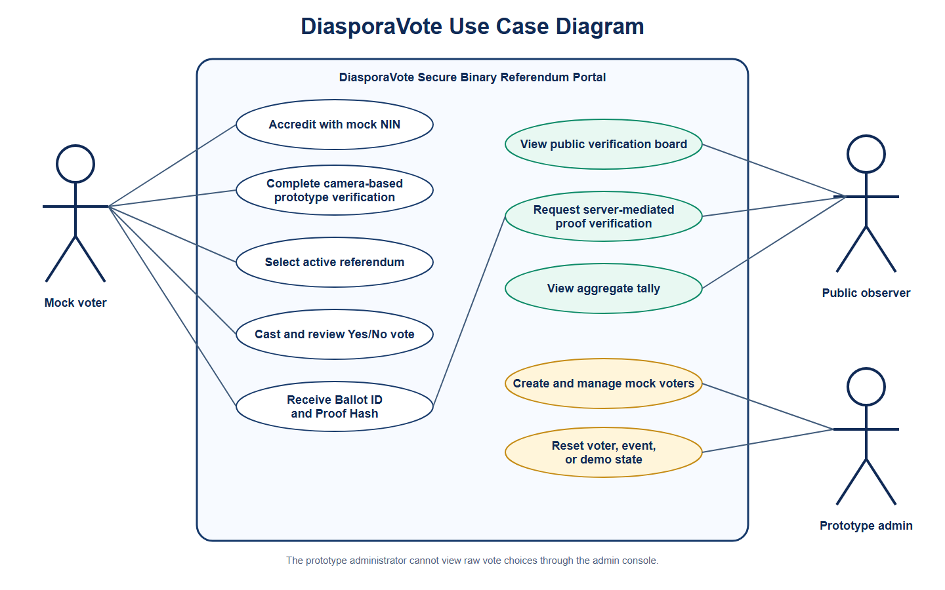
Figure 3.1: Use-case diagram for DiasporaVote actors
Requirement analysis defines what a system should do and the conditions under which it should operate. In this project, the requirements were derived from the aim of building a secure diaspora e-voting prototype using zk-STARK protocols. The analysis focused on the trust problems of remote voting, including voter eligibility, ballot privacy, duplicate-vote prevention, ballot validity, public verification, and tally correctness. Literature on verifiable online voting shows that online voting systems must provide evidence beyond ordinary vote submission messages because voters and observers need confidence that ballots were recorded and handled correctly (Ali & Murray, 2016; Alsadi et al., 2019). For this reason, the system requirements were structured around both user-facing voting functions and security-focused verification functions.

3.2.1 Functional Requirements
Functional requirements describe the operations and services that the system must provide. For this prototype, the functional requirements were selected to support the complete voting workflow from mock voter accreditation to tally display. The requirements also include administrative functions because the prototype uses a mock registry that must be populated and managed for demonstration. Table 3.1 presents the main functional requirements of the system.
Table 3.1: Functional Requirements of the System
S/N | Functional Requirement | Description
1 | Mock voter registry management | The system should allow an authorised prototype administrator to create, view, deactivate, delete, and reset mock eligible voters.
2 | Mock NIN accreditation | The system should allow a voter to submit a mock National Identification Number for accreditation against the controlled registry.
3 | Voter session creation | The system should create an authenticated session for a mock voter who passes registry checks.
4 | Camera-based prototype verification | The system should require a camera-based presence verification step before ballot access is granted.
5 | Event display | The system should display the active referendum event to an accredited and verified voter.
6 | Binary ballot casting | The system should allow the voter to select either Yes or No for the active referendum.
7 | Ballot review | The system should allow the voter to review the selected choice before submission.
8 | Vote-value validation | The system should reject ballot values outside the allowed binary options.
9 | Duplicate-vote prevention | The system should prevent the same voter from casting more than one ballot for the same event.
10 | zk-STARK proof generation | The system should generate a proof artifact through the Winterfell proof engine before ballot acceptance.
11 | zk-STARK proof verification | The system should verify the generated proof before the ballot record is stored.
12 | Encrypted ballot storage | The system should store the ballot in encrypted form after successful proof generation and verification.
13 | Public receipt generation | The system should return a Ballot ID and Proof Hash to the voter after successful ballot submission.
14 | Public verification board | The system should publish only privacy-preserving receipt metadata on the public verification board.
15 | Server-mediated proof verification | The system should allow users to request proof verification for a stored ballot through the backend.
16 | Event-aware tallying | The system should display aggregate Yes and No results for the active referendum based only on accepted ballot records.

The functional requirements show that the system was not designed as a basic online polling interface. Instead, the voting process was designed as a controlled workflow in which a voter must pass accreditation, presence verification, ballot validation, duplicate-vote checks, proof generation, and proof verification before a ballot is accepted. This design supports the project’s central argument that secure diaspora e-voting requires a trust architecture rather than only a web form. The public verification board also reflects the verifiability concerns discussed in electronic voting literature, where voters and observers need a way to check election records without exposing private ballot choices (Quaglia & Smyth, 2017). However, the system remains a prototype, so the verification process is server-mediated rather than fully independent on the voter’s device.

3.2.2 Non-Functional Requirements
Non-functional requirements describe the quality attributes and constraints under which the system should operate. In this project, these requirements were especially important because the system handles voting-related data and proof records. The prototype needed to protect sensitive information, support verification, remain usable to voters, and provide reliable results within the controlled referendum scenario. Table 3.2 presents the major non-functional requirements of the system.
Table 3.2: Non-Functional Requirements of the System
S/N | Non-Functional Requirement | Description
1 | Privacy | The system should not expose voter identity, full NIN, NIN hash, raw vote, decrypted vote, session token, or private proof path on the public board.
2 | Integrity | The system should ensure that accepted ballot records are tied to proof artifacts and proof hashes.
3 | Verifiability | The system should allow ballot receipt checking and server-mediated proof verification.
4 | Eligibility | The system should allow only active voters in the mock registry to access the voting flow.
5 | Duplicate-vote resistance | The system should reject a second ballot attempt by the same voter for the same event.
6 | Availability | The deployed frontend and backend should be reachable during demonstration and testing.
7 | Persistence | The backend should retain registry and ballot records across redeployments through persistent storage.
8 | Usability | The voter interface should guide users from accreditation to receipt without unnecessary complexity.
9 | Maintainability | The system should be structured into clear frontend, backend, proof, database, and admin components.
10 | Auditability | The system should provide traceable receipt metadata and verification responses without revealing sensitive private data.

The non-functional requirements were chosen to reflect the security and trust properties expected in a remote voting prototype. Privacy and verifiability are particularly important because they create a design tension: the system must reveal enough information to support public confidence while hiding enough information to protect the voter. This is why the public board publishes only receipt metadata instead of sensitive voting data. Integrity is also important because the proof hash must remain linked to the proof artifact used during ballot acceptance. These requirements do not make the prototype production-ready for national elections, but they provide a structured basis for implementing and evaluating the system within the project scope.

3.3 System Architecture
Figure 3.2: DiasporaVote system architecture is presented below.
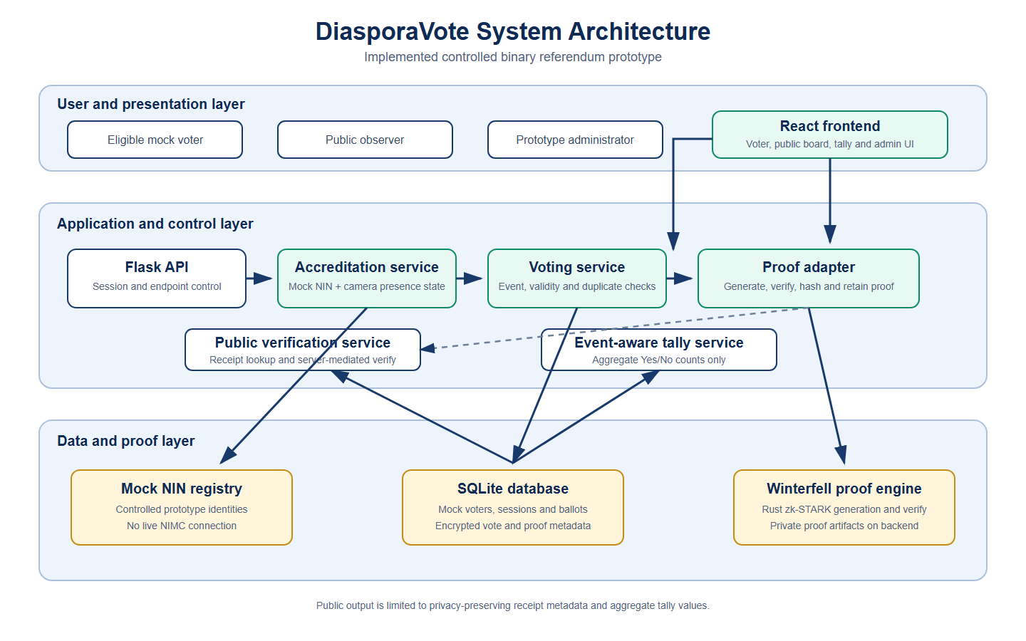
Figure 3.2: DiasporaVote system architecture
The system architecture describes the major components of the prototype and how they interact. The prototype was designed as a layered web-based system consisting of a React frontend, Flask backend, SQLite database, mock NIN identity layer, Winterfell-based zk-STARK proof engine, public verification board, event-aware tally module, and admin registry console. This layered design makes it easier to separate user interaction, business logic, cryptographic proof handling, persistent storage, and public verification. It also supports maintainability because each layer has a clearly defined role in the voting process.
The first layer is the presentation layer, which was implemented with React. This layer provides the user interface for voter accreditation, camera-based prototype verification, event selection, ballot casting, vote review, receipt display, public board viewing, tally viewing, and admin operations. The frontend does not independently decide whether a ballot is valid. Instead, it collects the required user input and sends requests to the backend for validation and processing. This reduces the risk of relying on client-side checks because frontend logic can be bypassed or modified by a malicious user. Therefore, all major voting decisions are handled by the backend.
The second layer is the backend application layer, which was implemented with Flask. This layer exposes the application programming interface endpoints used by the frontend. It handles mock NIN accreditation, session validation, camera-verification status, event retrieval, vote submission, proof verification, public board records, tally computation, and admin registry operations. The backend acts as the control point of the prototype because it checks whether a voter is active, whether the session is verified, whether the event is active, whether the submitted vote is valid, and whether the voter has already voted in that event. Only after these checks are completed does the backend proceed to proof generation and ballot storage.
The third layer is the mock identity and accreditation layer. In this layer, the system simulates a voter registry using mock NIN records. The voter’s submitted mock NIN is normalised and checked against the controlled registry. The registry stores safe identity metadata required for the prototype, such as masked NIN values and voter status, but the public verification board does not expose full NINs or NIN hashes. This design models the principle that a voting system must have an eligible voter roll without pretending to connect to live national identity infrastructure. The mock identity layer therefore supports demonstration and testing while keeping the project within a realistic academic scope.
The fourth layer is the voting protocol layer. This layer manages the active referendum, vote-value validation, duplicate-vote checks, encrypted ballot storage, receipt generation, and event-aware tallying. The active event used in the prototype is a binary referendum in which the voter selects either Yes or No. The binary design reduces unnecessary complexity while still supporting the main properties that matter in the project: eligibility, one-person-one-vote enforcement, ballot acceptance verification, privacy-preserving public receipts, and tally correctness. The voting protocol layer ensures that a ballot is not stored simply because the frontend sends a request. It must pass the backend checks and the proof-backed acceptance process.
The fifth layer is the zk-STARK proof layer, implemented through a Winterfell-based proof engine. The proof layer is responsible for generating and verifying proof artifacts connected to the ballot acceptance process. In the prototype workflow, the backend invokes the proof engine during vote submission, verifies the proof, computes a proof hash, and stores the ballot only after proof verification succeeds. This design follows the idea that cryptographic proof systems can provide evidence that defined computations were followed without exposing unnecessary private information (Goldwasser et al., 1989; Ben-Sasson et al., 2018). The proof layer does not replace identity checks, database checks, or backend access control; rather, it strengthens the acceptance workflow by adding proof-backed verification.
The sixth layer is the storage and public verification layer. SQLite was used to store voter records, event data, encrypted ballot records, proof hashes, timestamps, and verification-related metadata. The public verification board reads only safe public metadata from stored ballot records. It does not publish voter names, full NINs, NIN hashes, raw votes, decrypted votes, session tokens, or private proof paths. This ensures that the public board functions as a transparency layer without becoming a privacy leak. The same storage layer also supports event-aware tallying, where aggregate Yes and No totals are derived from accepted ballot records connected to the active event.

3.4 Threat Model
The threat model identifies likely risks against the prototype and explains how the system design responds to them. Since this project is a final year implementation, the threat model is limited to the controlled prototype environment and does not claim to cover every attack possible in a production national election. The model assumes that attackers may attempt to impersonate voters, submit invalid ballots, vote more than once, inspect public records, manipulate proof-related data, or abuse exposed interfaces. It also assumes that public trust can be weakened if voters cannot confirm that accepted ballots appear in the public record. Table 3.3 presents the major threats considered in the design.
Table 3.3: Threat Model and Mitigation Strategy
S/N | Threat | Description | Mitigation in the Prototype
1 | Impersonation | An attacker may attempt to vote using an unknown or inactive identity. | The system checks the submitted mock NIN against the controlled registry and rejects unregistered or inactive voters.
2 | Duplicate voting | A voter may attempt to cast more than one ballot in the same referendum. | The backend checks existing ballot status for the voter and event before accepting a new vote.
3 | Invalid ballot value | A user may submit a value outside the allowed Yes/No range. | The backend validates the vote value and accepts only the permitted binary options.
4 | Unverified session voting | A user may attempt to bypass the camera-based verification step. | The backend requires biometric or presence-verification status before permitting vote submission.
5 | Ballot manipulation | A ballot record may be altered after submission. | Accepted ballots are linked to proof hashes and verification metadata, making proof-linked changes detectable during verification.
6 | Proof artifact tampering | A proof artifact may be changed after storage. | The stored proof hash functions as a fingerprint of the proof artifact, so altered proof data should no longer match the published hash.
7 | Public privacy leakage | Public records may reveal sensitive voter or ballot details. | The public board exposes only safe receipt metadata and excludes voter identity, full NIN, NIN hash, raw vote, decrypted vote, session token, and private proof path.
8 | Tally manipulation | The displayed result may not reflect accepted ballots. | The tally is event-aware and derived from accepted ballot records rather than manual result entry.
9 | Admin misuse | Prototype registry controls may be misused to alter demonstration data. | Admin functions are separated from public voter functions and require admin authentication.
10 | Server trust weakness | Users may still need to depend on the backend for proof verification. | The system provides server-mediated proof verification and clearly identifies independent local verification as a future improvement.

The threat model shows that the prototype addresses several important remote voting risks, but it also exposes the limits of the current implementation. For example, the system reduces duplicate voting within the controlled database, but it does not solve all identity fraud problems that would exist in a real national deployment. It also provides server-mediated public verification, but it does not yet allow every voter to independently verify proofs locally. These limitations do not invalidate the prototype because the aim of the project is to demonstrate a secure workflow within a controlled academic scope. The important point is that the system was designed to make ballot acceptance more verifiable and tamper-evident than a normal online polling interface.

3.5 Voting Protocol Design
Figure 3.3: Voting workflow for the controlled referendum prototype is presented below.
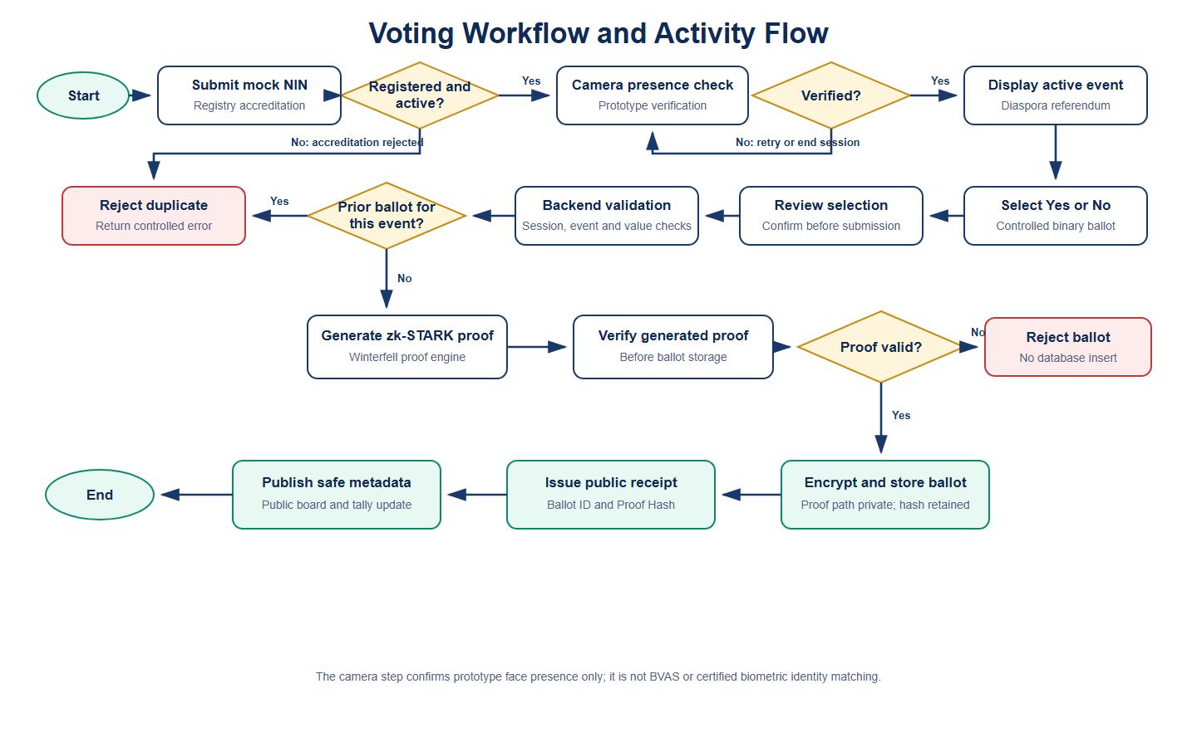
Figure 3.3: Voting workflow for the controlled referendum prototype
The voting protocol defines how a ballot moves from the voter to the tally. The protocol was designed to ensure that each accepted ballot passes through accreditation, verification, validation, proof generation, proof verification, encrypted storage, public receipt publication, and tally inclusion. This section describes the intended workflow in logical order. The protocol is based on the principle that a ballot should not be accepted simply because a user clicked a submit button. Instead, the system should confirm that the voter is eligible in the mock registry, the session is verified, the event is active, the vote value is valid, the voter has not voted before in that event, and the proof-backed acceptance step succeeds.
The first stage is mock registry preparation. The prototype administrator uses the admin console to manage eligible mock voters. A mock voter record contains controlled identity metadata such as display name, location, masked NIN, NIN last-four digits, and active status. The registry exists only for prototype demonstration and does not connect to live NIMC infrastructure. This stage represents the idea of a voter roll, which is necessary because voting cannot be open to unknown users. Without this step, the system would function like a public poll rather than a controlled voting prototype.
The second stage is voter accreditation. The voter submits a mock NIN through the accreditation page. The backend normalises the submitted value and checks whether the voter exists in the mock registry, whether the voter is active, and whether the voter is eligible for the active referendum. If the voter fails this check, the system rejects the attempt and does not create a valid voting session. If the voter passes the check, the backend returns a session that allows the voter to continue to the next stage. This stage models the electoral principle that only recognised eligible voters should access the ballot.
The third stage is camera-based prototype verification. After mock NIN accreditation, the voter completes a camera-based presence verification step. This is not BVAS and is not certified facial recognition. It is a prototype verification ceremony that adds a second step before ballot access is granted. The purpose is to strengthen the workflow by requiring the voter to pass an additional presence check before reaching the ballot. Once this step is completed, the session is marked as verified and the voter can proceed to the active referendum event.
The fourth stage is ballot selection and review. The voter selects the active event and is shown the binary referendum question. The ballot allows only two choices: Yes or No. The voter selects a choice and reviews it before final submission. This review step reduces accidental submission and makes the voting flow more understandable. The binary ballot was chosen because it keeps the constraint system focused while still demonstrating the major security properties required in the project.
The fifth stage is backend ballot validation. When the vote is submitted, the backend checks the session token, verification status, event status, vote value, voter eligibility, and duplicate-vote status. If any condition fails, the vote is rejected before proof generation and storage. If the conditions pass, the submitted choice is encoded as a binary value suitable for the proof workflow. This stage is important because client-side validation alone cannot be trusted. A malicious user could bypass frontend rules and send direct requests to the backend, so the backend must enforce all major voting rules.
The sixth stage is proof-backed ballot acceptance. The backend invokes the Winterfell proof engine to generate a zk-STARK proof artifact connected to the ballot validity workflow. The backend then verifies the generated proof. If proof verification fails, the ballot is not stored. If proof verification succeeds, the system encrypts the ballot record, computes the proof hash, stores the accepted ballot metadata, and marks the voter as having voted in that event. This stage is the main technical contribution of the prototype because ballot storage depends on proof generation and verification in addition to normal backend checks.
The seventh stage is public receipt publication. After successful ballot acceptance, the system returns a Ballot ID and Proof Hash to the voter. The Ballot ID allows the voter to find the ballot record on the public verification board. The Proof Hash acts as a fingerprint of the proof artifact connected to the ballot. The public board displays only safe metadata, including Ballot ID, Proof Hash, event details, timestamp, and verification status. It does not display the voter’s identity or selected choice. This supports transparency while protecting ballot privacy.
The final stage is tallying. The tally module counts accepted ballots for the selected event and displays aggregate Yes and No totals. The tally is event-aware, meaning it is linked to the active referendum and not treated as a single global count across unrelated events. The tally is derived from accepted ballot records rather than manual result entry. This supports the principle that only ballots that pass the voting workflow, including proof verification, should be included in the displayed result. The protocol can be summarised in the following pseudocode:
function submit_vote(session_token, event_id, vote_choice): validate session_token confirm voter is accredited confirm camera_verification_status is true confirm event_id is active confirm vote_choice is Yes or No confirm voter has not voted in event_id encode vote_choice as binary value generate zk-STARK proof artifact verify generated proof if proof verification fails: reject ballot encrypt vote_choice compute proof hash store accepted ballot record mark voter as voted for event_id publish safe receipt metadata return Ballot ID and Proof Hash

3.6 zk-STARK Constraint System Design
Figure 3.4: zk-STARK proof verification flow is presented below.
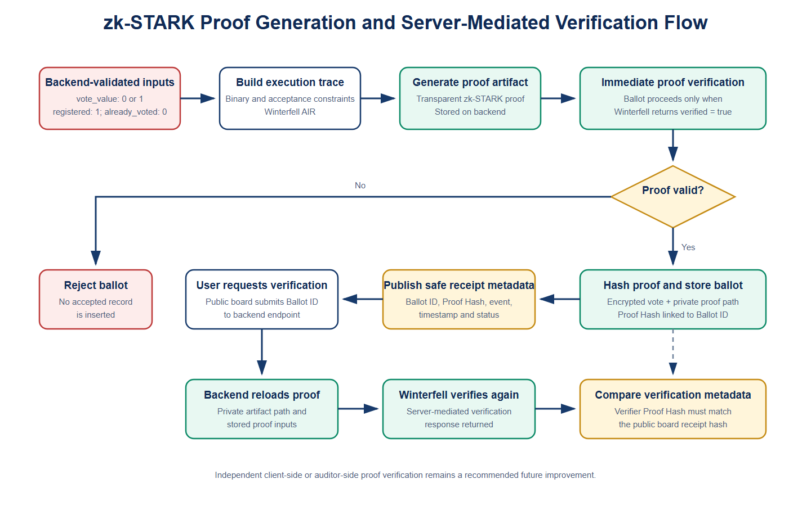
Figure 3.4: zk-STARK proof verification flow
The zk-STARK constraint system design explains the rules that guide proof-backed ballot acceptance in the prototype. A zk-STARK proof system is useful because it can provide evidence that a computation followed defined rules without exposing unnecessary private information (Ben-Sasson et al., 2018). In this study, the proof system was used within a controlled binary referendum scenario. The design goal was not to build a full national cryptographic voting protocol, but to demonstrate how proof generation and verification can be integrated into a secure voting workflow. The constraint design was therefore kept focused on ballot validity and proof-backed acceptance.
The basic ballot domain constraint is that the vote must be one of the allowed binary values. In the prototype, Yes and No are encoded as binary values, such as 1 and 0. A simple arithmetic expression for this rule is v(v - 1) = 0, where v represents the encoded vote value. This expression is true only when v is 0 or 1. If the user submits a value outside the allowed range, the backend rejects the submission before storage. This keeps the ballot format controlled and prevents unsupported ballot values from entering the accepted ballot record.
The eligibility and duplicate-vote rules are enforced at the system level before proof-backed storage. The backend checks whether the voter exists in the mock registry, whether the voter is active, whether the session has passed camera-based verification, and whether a ballot has already been cast by that voter for the same event. These checks are important because a voting system must prevent unknown users and repeat votes from entering the election record. In a stronger future cryptographic design, eligibility and duplicate-vote prevention could be represented through cryptographic membership proofs, nullifiers, and registry commitments. In the current prototype, they are enforced through the backend and database before the proof-backed acceptance step.
The proof artifact is linked to the public verification process through a proof hash. After the proof engine generates and verifies the proof, the backend computes a hash of the proof artifact. This proof hash is stored with the accepted ballot record and published on the public verification board. If the proof artifact is altered later, it should no longer match the published proof hash. This makes the record tamper-evident at the prototype level. The proof hash by itself is not the complete guarantee, but it becomes meaningful when connected to proof verification through the backend verification endpoint.
The proof verification process is server-mediated in the current implementation. This means that users request the backend to re-run verification for a stored proof rather than verifying the proof independently on their own devices. This is an important design limitation that must be stated clearly. However, server-mediated verification still demonstrates the core workflow: a ballot is accepted only after proof generation and verification, the public board records the proof hash, and the verification endpoint confirms whether the stored proof remains valid. The design therefore provides a practical final year demonstration of proof-backed ballot acceptance while leaving fully independent local proof verification as future work.
The design of the constraint system can be summarised as follows:
The submitted vote must belong to the allowed binary ballot domain.
The voter must pass mock registry accreditation before ballot access.
The voter session must pass camera-based prototype verification before vote submission.
The voter must not have previously voted in the same event.
The proof engine must generate a proof artifact for the accepted ballot workflow.
The backend must verify the proof before storing the encrypted ballot.
The stored ballot record must be linked to a public proof hash.
The public board must expose only privacy-preserving receipt metadata.
This design keeps the project honest and defensible. It does not claim that every election property is proven entirely inside the zk-STARK circuit. Instead, it presents the prototype as a layered system where backend controls, database constraints, encrypted storage, proof generation, proof verification, and public proof hashes work together to support a secure remote voting workflow. This layered approach is appropriate for the scope of the project because it demonstrates the role of zk-STARKs without pretending that cryptography alone solves every problem in diaspora voting.

3.7 Database Design
Figure 3.5: Database and entity-relationship design is presented below.
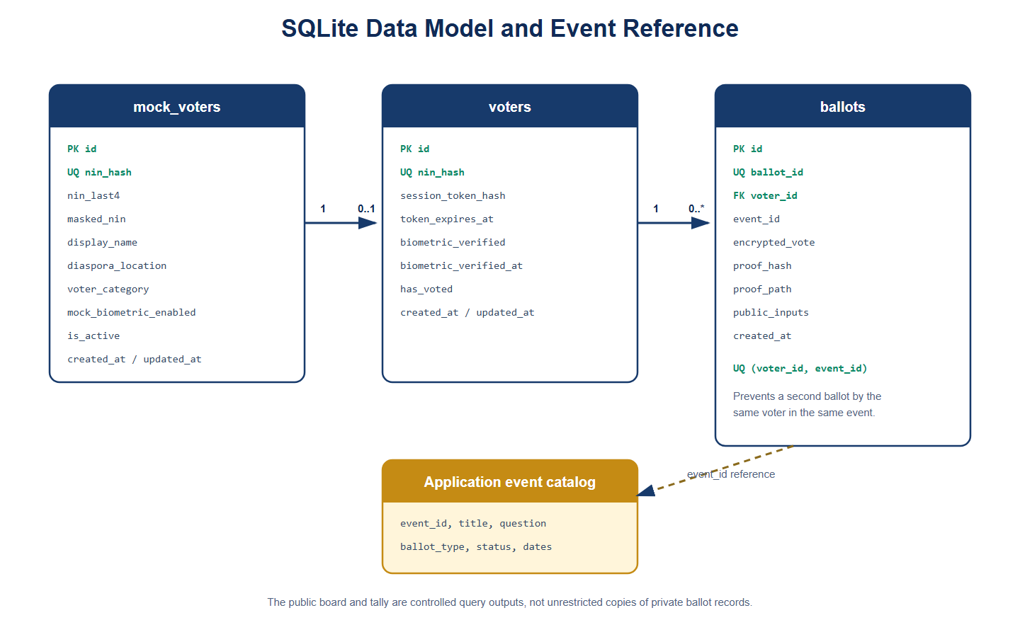
Figure 3.5: Database and entity-relationship design
The database design describes how the prototype stores the data required for mock voter management, event management, ballot storage, proof-linked receipts, public verification, and tallying. SQLite was selected as the database for the prototype because it is lightweight, easy to deploy, and suitable for a controlled final year implementation. The database supports persistence for voters, events, accepted ballots, proof hashes, and tally-related records. Since the public verification board must not expose sensitive voter or ballot information, the database design separates private backend records from public board metadata.
The voter table stores mock eligible voter records. It supports the controlled registry used for accreditation and admin demonstration. The table includes identity-related fields needed for the prototype, but sensitive values are not exposed on the public board. The system uses masked values for display and backend-controlled identity checks for accreditation. Table 3.4 summarises the main voter table design.
Table 3.4: Voter Table Design
Field | Description
voter_id | Unique internal identifier for the mock voter.
display_name | Name used for prototype admin display.
nin_hash | Hashed form of the mock NIN used for accreditation checks.
nin_last4 | Last four digits of the mock NIN used for safe admin display.
masked_nin | Masked representation of the mock NIN.
location | Mock diaspora location of the voter.
active | Indicates whether the mock voter is active.
biometric_verified | Indicates whether the current session has passed prototype verification where stored.
created_at | Timestamp showing when the mock voter record was created.

The event table stores referendum event information. The prototype includes one active binary referendum event and may also include additional demo events for interface realism. The active referendum is the event used for actual voting in the project demonstration. Table 3.5 presents the event table design.
Table 3.5: Event Table Design
Field | Description
event_id | Unique identifier for the referendum event.
title | Title of the voting event.
question | Referendum question displayed to voters.
ballot_type | Type of ballot, such as binary referendum.
status | Event status, such as active, upcoming, or closed.
created_at | Timestamp showing when the event was created.

The ballot table stores accepted ballot records. This table is central to the system because it links encrypted ballot storage with proof-backed receipt metadata. The table stores encrypted vote values for backend tallying, proof hashes for public receipt checking, and event identifiers for event-aware tallying. Sensitive values such as decrypted votes and private proof paths are not displayed publicly. Table 3.6 summarises the ballot table design.
Table 3.6: Ballot Table Design
Field | Description
ballot_id | Unique public-facing identifier for the accepted ballot.
voter_id | Internal reference to the mock voter record.
event_id | Identifier of the event for which the ballot was cast.
encrypted_vote | Encrypted representation of the submitted vote choice.
proof_hash | Hash fingerprint of the proof artifact linked to the ballot.
proof_path | Private backend path to the proof artifact, not exposed publicly.
public_inputs | Public verification inputs or metadata used by the proof workflow.
verification_status | Indicates whether the proof was verified.
created_at | Timestamp showing when the ballot was accepted.

The public board is not a separate unrestricted copy of the ballot table. Instead, it is a controlled public view that exposes only safe metadata. This design prevents the transparency layer from becoming a privacy leak. Table 3.7 shows the difference between data that can be displayed publicly and data that must remain private.
Table 3.7: Public and Private Verification Data
Data Item | Public Board Status | Reason
Ballot ID | Public | Allows the voter to find the accepted ballot receipt.
Proof Hash | Public | Links the receipt to the proof artifact fingerprint.
Event Title | Public | Shows the event connected to the ballot.
Timestamp | Public | Supports auditability and receipt checking.
Verification Status | Public | Shows whether proof verification succeeded.
Voter Name | Private | Could identify the voter.
Full NIN | Private | Sensitive identity data.
NIN Hash | Private | Could become a linkable identifier.
Raw Vote | Private | Would reveal ballot choice.
Decrypted Vote | Private | Would reveal ballot choice.
Session Token | Private | Could compromise voter session security.
Private Proof Path | Private | Internal backend storage detail.

The tally design uses accepted ballot records connected to a specific event. The system counts Yes and No votes for the active referendum and displays the total number of ballots cast. It also supports registered-voter and remaining-voter counts in the demonstration. The tally is not manually entered by an administrator; it is derived from stored ballot records. This supports tally correctness within the prototype because the displayed result depends on accepted ballots rather than a separate result-entry process.
Overall, the database design supports the main security and verification goals of the prototype. The voter table supports mock accreditation, the event table supports event-aware voting, the ballot table supports encrypted storage and proof-linked receipts, and the public board view supports privacy-preserving verification. The design also supports the project’s scope by avoiding live national identity records, real INEC infrastructure, polling-unit collation, party-based elections, or full presidential-election workflows. It provides only the data structures needed to demonstrate a secure binary diaspora referendum prototype using zk-STARK proof-backed ballot acceptance.

CHAPTER FOUR: SYSTEM IMPLEMENTATION, EVALUATION, AND DISCUSSION

4.1 Preamble
This chapter presents the implementation and evaluation of the secure diaspora e-voting prototype developed in this study. The chapter explains the system requirements, implementation tools, development approach, evaluation criteria, evaluation results, benchmarking discussion, security analysis, and program modules. The system was implemented as a web-based technical prototype that combines mock voter accreditation, camera-based prototype verification, binary referendum voting, zk-STARK proof generation and verification, encrypted ballot storage, public receipt verification, and event-aware tallying. The implementation was limited to a controlled binary referendum scenario in order to keep the cryptographic proof workflow focused and testable. The chapter therefore describes the implemented prototype as a proof-backed remote voting workflow, not as a full national election platform or a replacement for live electoral infrastructure.

4.2 System Requirements
System requirements describe the hardware and software resources needed to develop, test, deploy, and demonstrate the prototype. Since the system was implemented as a web-based application, the requirements covered both the development environment and the user environment. The development environment required tools for frontend development, backend development, database management, proof generation, proof verification, deployment, and browser-based testing. The user environment required only a modern web browser, internet access, and camera permission for the prototype verification stage. The system was designed to be lightweight enough for academic demonstration while still supporting the major security properties required by the project.

4.2.1 Hardware Requirements
The prototype did not require specialised election hardware because it was implemented as a web-based system. The main hardware requirement was a development computer capable of running the frontend, backend, database, and proof engine during local testing. A camera-enabled device was also required to test the camera-based prototype verification step. Table 4.1 presents the hardware requirements for the system.
Table 4.1: Hardware Requirements
S/N | Hardware Requirement | Description
1 | Development computer | A laptop or desktop computer used to develop and test the React frontend, Flask backend, SQLite database, and proof engine.
2 | Processor | A modern processor capable of running the backend server, frontend development server, and proof-generation process during testing.
3 | Memory | At least 8GB RAM is recommended for smooth development, browser testing, and running backend services.
4 | Storage | At least 10GB of free storage is recommended for project files, dependencies, database files, proof artifacts, and deployment builds.
5 | Camera | A webcam or device camera is required to test the camera-based prototype verification step.
6 | Internet connection | Internet access is required for deployment testing, frontend-backend communication, and hosted demonstration.

4.2.2 Software Requirements
The software requirements covered the tools, frameworks, and platforms used to implement and deploy the prototype. The frontend was implemented with React, while the backend was implemented with Flask. SQLite was used for persistent data storage, and a Winterfell-based proof engine was used for zk-STARK proof generation and verification. Table 4.2 presents the software requirements of the system.
Table 4.2: Software Requirements
S/N | Software Requirement | Purpose
1 | React | Used to implement the voter interface, public verification board, tally dashboard, and admin console.
2 | Vite | Used as the frontend development and build tool for the React application.
3 | Python | Used as the backend programming environment.
4 | Flask | Used to implement the backend API endpoints and server-side voting logic.
5 | SQLite | Used to store mock voters, election events, accepted ballots, proof hashes, and verification metadata.
6 | Rust | Used to support the Winterfell-based proof engine.
7 | Winterfell | Used as the zk-STARK proof generation and verification framework.
8 | Railway | Used to deploy the Flask backend and persistent backend volume.
9 | Vercel | Used to deploy the React frontend.
10 | Web browser | Used to access and test the voter interface, public board, tally page, and admin console.

4.3 Implementation Tools
The prototype was implemented using a combination of frontend, backend, database, cryptographic proof, and deployment tools. Each tool was selected because it supported a specific part of the project’s technical objective. React was used for the user-facing interface, Flask was used for backend logic and API routing, SQLite was used for storage, and Winterfell was used for zk-STARK proof generation and verification. The implementation also used a mock NIN simulation layer to represent controlled voter accreditation without connecting to a live national identity database. This section explains the major implementation tools used in the system.

4.3.1 Python and Flask
Python was used for the backend implementation because it provides a clear and flexible environment for building web services and managing application logic. Flask was used as the backend web framework. The Flask backend handled the core voting operations, including mock NIN accreditation, login, session validation, camera-verification status, event retrieval, vote submission, proof verification, public board records, tally computation, and admin operations. The backend also acted as the security control point because it enforced voter eligibility, event status, vote-value validation, duplicate-vote prevention, and proof verification before ballot storage. This ensured that the system did not rely on frontend checks alone.
The backend exposed several application programming interface endpoints to support the voting workflow. These included endpoints for registration, login, camera-based verification, vote submission, proof verification, public board retrieval, tally retrieval, event retrieval, health checking, proof-engine health checking, and admin registry operations. The vote submission endpoint was especially important because it controlled whether a ballot would be accepted. A ballot was stored only after the backend confirmed the voter session, checked the event, validated the vote value, checked duplicate-vote status, generated a proof, verified the proof, encrypted the ballot, computed the proof hash, and stored the accepted ballot record.

4.3.2 React
React was used to implement the frontend of the prototype. The frontend provided the screens and workflows needed by voters and administrators. For voters, the interface supported landing-page access, mock NIN accreditation, camera-based prototype verification, event selection, binary ballot selection, vote review, ballot submission, receipt display, public verification-board access, and tally viewing. For administrators, the interface supported mock voter registry management and prototype reset operations. The frontend was designed to guide users through the voting process in a clear sequence so that they would understand when they were being accredited, verified, allowed to vote, and given a receipt.
The React frontend did not independently decide whether a voter was eligible or whether a ballot was valid. Instead, it sent requests to the Flask backend and displayed the backend response. This design was necessary because client-side validation can be bypassed by a malicious user. The frontend therefore served mainly as the presentation and interaction layer, while the backend enforced the voting rules. The frontend was also configured to communicate with the deployed backend through an environment variable, allowing the hosted Vercel frontend to connect to the Railway backend.

4.3.3 Winterfell Proof Engine
Winterfell was used as the zk-STARK proof engine for the prototype. The proof engine was responsible for generating and verifying proof artifacts connected to the ballot acceptance process. The system used Winterfell after an earlier exploration of Cairo was discontinued due to an upstream verification issue that affected the proof workflow. Winterfell was selected for the final implementation because it successfully supported proof generation and verification for the controlled binary ballot scenario. The implemented proof engine generated and verified proofs for valid Yes and No ballot values.
The proof engine was integrated into the backend voting workflow. When a voter submitted a ballot, the backend checked the normal voting conditions and then invoked the proof engine. The generated proof was verified before the encrypted ballot record was stored. If proof verification failed, the ballot was not accepted. After successful verification, the backend computed a proof hash and stored it with the accepted ballot record. This proof hash was displayed on the public verification board as part of the voter’s receipt metadata. Early proof-size results were approximately 4,521 to 4,523 bytes for valid binary ballot proofs.

4.3.4 SQLite
SQLite was used as the database for the prototype. It was selected because it is lightweight, easy to configure, and suitable for a controlled final year implementation. The database stored mock voter records, election events, accepted ballots, encrypted vote values, proof hashes, proof-related metadata, and timestamps. SQLite also supported event-aware tallying by allowing the backend to count accepted ballots linked to the active referendum event. The use of SQLite made the system easier to deploy and test because it did not require a separate managed database service during prototype demonstration.
The database was connected to persistent backend storage during deployment. This was important because ballot and registry records needed to remain available after redeployment. Deployment testing confirmed that a ballot record remained available after backend redeployment, which showed that the persistence configuration worked within the prototype environment. The public board did not expose the full ballot table. Instead, it displayed only safe public metadata such as Ballot ID, Proof Hash, event details, timestamp, and verification status. Sensitive data such as voter identity, full NIN, NIN hash, raw vote, decrypted vote, session token, and private proof path were not published on the public board.

4.3.5 Mock NIN Simulation Layer
The mock NIN simulation layer was implemented to model voter accreditation without connecting the prototype to live national identity infrastructure. In the system, a voter submits a mock National Identification Number, which the backend normalises and checks against the controlled mock registry. Only active voters in the registry can proceed to the voting workflow. This layer allows the prototype to demonstrate the principle of eligibility checking while remaining within the ethical and technical scope of a student implementation. It does not connect to the National Identity Management Commission database and does not claim to validate real national identity records.
The mock NIN layer also supports admin-controlled demonstration. Through the admin console, authorised prototype administrators can create, view, deactivate, delete, and reset mock voters. The admin view displays safe identity metadata such as masked NIN and NIN last-four digits, rather than exposing full sensitive identity values. This design supports testing and demonstration while reducing privacy risks. It also keeps the system aligned with the project’s controlled referendum scope.

4.4 Development Methodology
The system was developed using an iterative technical implementation approach. The development process began with requirement identification and system design, followed by implementation of the backend, frontend, database, proof engine, admin console, deployment configuration, and evaluation tests. The implementation was guided by the project objectives, which required the system to review existing e-voting approaches, analyse diaspora voting security requirements, design a zk-STARK-based ballot validity workflow, implement the working prototype, and evaluate its security and performance properties. The development process therefore moved from concept to implementation in stages.
The first implementation stage focused on the backend foundation. This included setting up the Flask API, defining the mock voter registry, implementing login and accreditation logic, creating the event model, and building the voting endpoint. The backend was designed to reject unregistered voters, inactive voters, invalid vote values, unverified sessions, and duplicate voting attempts. This stage established the core server-side rules that controlled ballot access and acceptance.
The second stage focused on the frontend workflow. The React frontend was built to guide users through the voting process. The workflow began with the landing page and continued through mock NIN accreditation, camera-based prototype verification, event selection, ballot selection, review, submission, receipt display, public verification, and tally viewing. This stage was important because a secure voting prototype also needs to be understandable to users. A system that is secure but confusing can still fail in practice, especially in remote voting contexts.
The third stage focused on proof integration. The Winterfell proof engine was connected to the backend vote-submission workflow. The backend generated and verified proof artifacts before storing accepted ballots. Proof hashes were then computed and linked to public ballot receipts. This stage converted the system from a normal voting web application into a proof-backed voting prototype, since ballot acceptance became dependent on proof generation and proof verification.
The fourth stage focused on public verification and tallying. The public board was implemented to display only privacy-preserving receipt metadata. The tally module was implemented to count accepted ballots by event and display Yes, No, total cast, registered voters, and remaining voters where applicable. This stage allowed voters and observers to inspect the public receipt layer and view aggregate results without seeing private ballot choices.
The fifth stage focused on deployment and testing. The backend was deployed on Railway, while the frontend was deployed on Vercel. Environment variables were configured so that the frontend could communicate with the backend and the backend could allow the deployed frontend origin. A Railway volume was used to support persistent backend storage. Smoke testing was then carried out to confirm health checks, voter login, camera verification, vote submission, proof generation, proof verification, public board visibility, tally update, admin operations, and persistence after redeployment.

4.5 Evaluation of the System
The system evaluation examined whether the implemented prototype satisfied the main functional and security expectations of the project. The evaluation focused on workflow correctness, proof generation and verification, duplicate-vote rejection, privacy-preserving public metadata, tally correctness, deployment behaviour, and persistence. Since the system is a controlled prototype, the evaluation did not claim to test national-scale election security or real institutional integration. Instead, it examined whether the implemented system performed correctly within the defined binary referendum scope.

4.5.1 Evaluation Criteria
The evaluation criteria were derived from the project objectives and system requirements. The criteria were selected to test both normal user workflow and security-focused behaviour. Table 4.3 presents the evaluation criteria used for the prototype.
Table 4.3: Evaluation Criteria
S/N | Evaluation Criterion | Expected Behaviour
1 | Mock voter accreditation | The system should allow only registered and active mock voters to proceed.
2 | Unregistered voter rejection | The system should reject NIN values that are not in the mock registry.
3 | Camera-based verification | The system should require the prototype verification step before ballot access.
4 | Valid ballot submission | The system should accept only Yes or No votes for the active referendum.
5 | Invalid vote rejection | The system should reject unsupported ballot values.
6 | Duplicate-vote prevention | The system should prevent a voter from voting twice in the same event.
7 | Proof generation | The system should generate a zk-STARK proof artifact for valid ballot submissions.
8 | Proof verification | The system should verify the generated proof before ballot storage.
9 | Public receipt display | The system should return a Ballot ID and Proof Hash after successful voting.
10 | Public board privacy | The public board should not expose voter identity, full NIN, NIN hash, raw vote, decrypted vote, session token, or private proof path.
11 | Event-aware tally | The tally should count accepted ballots for the active referendum event.
12 | Deployment availability | The deployed frontend and backend should be reachable during testing.
13 | Data persistence | Registry and ballot records should persist after backend redeployment.
14 | Admin registry management | The admin console should support controlled creation and management of mock voters.

4.5.2 Evaluation Results
Direct proof-engine benchmarking was conducted after functional evaluation to provide measured evidence for proof-generation and proof-verification cost within the prototype.
Table 4.5A: Direct Winterfell proof-engine benchmark summary
Case | Runs | Avg. Gen. (ms) | Avg. Ver. (ms) | Avg. Proof Size (bytes)
Yes | 30 | 0.8141 | 0.5196 | 4523
No | 30 | 0.7186 | 0.4011 | 4521

The evaluation showed that the prototype satisfied the major functional requirements within the defined project scope. The system allowed eligible mock voters to pass accreditation and blocked unregistered voters. It required the camera-based prototype verification step before voting. It accepted valid Yes and No ballot values and rejected invalid voting conditions. It also prevented duplicate voting by the same voter within the same referendum event. Table 4.4 summarises the evaluation results.
Table 4.4: Functional Evaluation Results
S/N | Test Case | Result | Comment
1 | Registered mock voter login | Passed | A registered mock voter was able to log in and receive a session.
2 | Unregistered voter attempt | Passed | Unregistered voter details were rejected.
3 | Camera-based prototype verification | Passed | The voting flow required verification before ballot submission.
4 | Valid Yes vote submission | Passed | A valid Yes vote generated a proof-backed ballot receipt.
5 | Valid No vote submission | Passed | The proof engine supported valid binary ballot proofs.
6 | Invalid vote value | Passed | Unsupported vote values were rejected.
7 | Duplicate vote attempt | Passed | A second vote attempt by the same voter for the same event was rejected.
8 | Proof engine health check | Passed | The backend confirmed that the proof engine was available.
9 | Proof verification endpoint | Passed | Stored ballot proof verification returned a valid verification response.
10 | Public board privacy check | Passed | The public board exposed only safe receipt metadata.
11 | Event-aware tally | Passed | The tally counted accepted ballots for the referendum event.
12 | Admin mock voter creation | Passed | A mock voter was created and appeared in the admin registry list.
13 | Deployment smoke test | Passed | The deployed frontend and backend were accessible during testing.
14 | Persistence after redeployment | Passed | A stored ballot remained available after backend redeployment.

A deployment smoke test confirmed that the backend health endpoint returned an active status and that the proof engine was available. A registered mock voter was able to log in, complete the verification step, submit a valid ballot, receive a Ballot ID and Proof Hash, verify the stored proof, and observe the tally update. One recorded test produced a valid ballot receipt with the event identifier linked to the active diaspora referendum. The corresponding tally updated to show one accepted Yes vote, zero No votes, one total ballot cast, four registered mock voters, and three remaining voters. A persistence test after redeployment confirmed that the stored ballot record and verification response remained available.
The proof-size result observed during early testing was approximately 4,521 to 4,523 bytes for valid binary ballot proofs. This size is suitable for prototype-level storage and receipt linkage because the public board does not need to expose the full proof artifact. Instead, the public board exposes the proof hash, while the backend maintains the private proof artifact path for server-mediated verification. Final average proof generation time and proof verification time should be inserted after the final benchmark run is completed. These timing values should be measured using repeated benchmark runs and reported as averages to avoid relying on a single execution result.

4.5.3 Benchmarking Against Existing Systems
Benchmarking was carried out as a comparative discussion rather than a claim that the prototype is more complete than existing verifiable voting systems. Systems such as Helios and Belenios are more mature and have broader voting-system features. However, they are not designed specifically around the Nigerian diaspora context, mock NIN-style accreditation, or zk-STARK proof-backed ballot acceptance. The purpose of the comparison was therefore to position the prototype in relation to existing systems and show what it demonstrates within its controlled scope. Table 4.5 presents the comparative benchmark.
Table 4.5: Comparative Benchmark Against Existing Systems
Feature | Helios | Belenios | Implemented Prototype
Main focus | Web-based open-audit voting | Verifiable online voting with vote privacy and public tally verification | Secure diaspora e-voting prototype for a binary referendum
Identity model | Election-specific voter credentials | Voter credentials and election administration controls | Mock NIN registry and camera-based prototype verification
Ballot format | Supports online election ballots | Supports different election formats, including referendums | Controlled Yes/No binary referendum
Cryptographic focus | Encrypted ballots and public auditability | Encrypted voting, public ballot box, and public verification | zk-STARK proof-backed ballot acceptance with encrypted storage
Public record | Public audit trail | Public ballot box and verification material | Public verification board with Ballot ID and Proof Hash
Verification model | Public auditability | Public verifiability | Server-mediated proof verification
Diaspora/Nigerian context | Not specific to Nigeria or diaspora voting | Not specific to Nigeria or diaspora voting | Designed around a Nigerian diaspora voting scenario
Live national identity integration | Not applicable | Not applicable | Not implemented; uses mock NIN simulation
Production maturity | More mature research/prototype system | Mature verifiable voting platform | Final year technical prototype
Main limitation for this project context | Does not use zk-STARK proof-backed ballot acceptance or Nigerian accreditation framing | Does not use mock NIN-style accreditation or zk-STARK acceptance gate | Not production-grade and does not yet support independent local verification

The comparison shows that the implemented prototype is narrower than Helios and Belenios in election scope, but more specific to the research problem of this study. Its main contribution is not broad election administration. Its contribution is the integration of a Nigerian diaspora-inspired mock accreditation workflow with zk-STARK proof generation, proof verification, encrypted ballot storage, public receipt metadata, and event-aware tallying. This makes the prototype useful as an academic demonstration of a proof-backed remote voting workflow.

4.5.4 Security Analysis
The security analysis examined how the implemented system addressed the main risks identified in the threat model. The first security property considered was eligibility. The system supported eligibility through a mock NIN registry. A voter had to exist in the controlled registry and remain active before continuing through the voting process. This prevented unknown users from directly accessing the ballot through the normal workflow. The system did not claim to validate real NIN records, since it did not connect to live NIMC infrastructure.
The second security property was duplicate-vote prevention. The backend checked whether a voter had already cast a ballot for the same event before accepting a new vote. This was important because one-person-one-vote enforcement is a core requirement in voting systems. The duplicate-vote check was scoped per voter and per event, allowing the system to support event-aware voting rather than using a single global vote status across all possible events.
The third security property was ballot validity. The prototype used a controlled binary ballot format, so valid votes were limited to Yes and No. The backend rejected unsupported vote values before storage. The Winterfell proof engine then generated and verified proof artifacts for valid binary ballot workflows. This added a proof-backed acceptance layer to the voting process. The system therefore did not rely only on a frontend confirmation message.
The fourth security property was privacy-preserving public verification. The public verification board displayed only safe receipt metadata. It did not expose voter names, full NINs, NIN hashes, raw votes, decrypted votes, session tokens, or private proof paths. This protected voters from direct exposure through the public board. However, the system did not claim complete production-grade anonymity because the backend still handled encrypted vote storage and tallying within the prototype environment.
The fifth security property was tamper-evidence. The proof hash acted as a fingerprint of the proof artifact connected to an accepted ballot. If the proof artifact changed, the hash would no longer match the stored and displayed proof hash. This made proof-linked ballot records more tamper-evident than ordinary database entries. The proof hash alone was not treated as a complete guarantee, but it became meaningful when combined with server-mediated proof verification.
The sixth security property was tally correctness within the prototype scope. The tally was derived from accepted ballot records connected to the active event. It was not manually entered by an administrator. This reduced the risk of displaying results that were disconnected from stored ballot records. The tally module counted Yes and No votes and showed aggregate results without exposing individual ballot choices.
The final security point concerns the limit of server-mediated verification. In the current prototype, users request the backend to verify stored proofs. This demonstrates the verification workflow, but it is not the same as full independent local verification by voters or external auditors. A stronger future version would allow users or observers to download public proof material and independently verify it outside the election server. This limitation is important because it keeps the project claims honest and academically defensible.

4.5.5 Discussion
The implemented prototype successfully demonstrated the main workflow required by the study. A mock diaspora voter could be accredited, pass camera-based prototype verification, select the active binary referendum, submit a vote, trigger zk-STARK proof generation and verification, receive a public receipt, check the public board, and observe tally updates. This shows that the project was implemented as more than a simple online voting interface. The backend controlled the voting workflow, the proof engine supported proof-backed acceptance, the database stored encrypted ballot records, and the public board provided receipt-based transparency.
The use of a binary referendum was appropriate for the project scope. A full national election with candidates, parties, polling units, wards, local government areas, states, and collation would have introduced unnecessary complexity that could distract from the cryptographic proof objective. The binary referendum allowed the implementation to focus on the essential voting properties: eligibility, duplicate-vote prevention, ballot validity, proof-backed acceptance, public receipt verification, and tally correctness. This made the system testable within the timeframe of a final year project.
The mock NIN layer was also appropriate because it allowed the system to demonstrate voter accreditation without making false claims about live national identity integration. This is important because connecting to real identity systems would require institutional permission, legal agreements, production security controls, and privacy safeguards beyond the scope of the study. The mock layer therefore served as a controlled simulation of the identity-checking role that a real diaspora voting system would require.
The Winterfell proof engine strengthened the prototype by making proof generation and verification part of ballot acceptance. This made the system different from a basic poll application where the server simply stores whatever the frontend submits. However, the implementation also shows that cryptography alone is not enough. The system still needed backend access control, registry checks, event checks, duplicate-vote prevention, encrypted storage, public-board filtering, and tally logic. The most accurate interpretation of the system is therefore a layered trust architecture, where zk-STARK proof verification is one important layer among several.
The evaluation also revealed areas for future improvement. The current public verification model is server-mediated, not fully independent. The camera-based verification step is a prototype presence check, not certified biometric identity matching. The mock NIN registry does not connect to live NIMC infrastructure. The tally is event-aware within the prototype, but the system does not implement national collation or multi-level result aggregation. These limitations do not weaken the project when stated honestly because the objective was to implement a focused, secure diaspora voting prototype rather than a production national voting system.

4.6 Program Modules and Interfaces
Figure 4.1: Landing page of the DiasporaVote prototype is presented below.
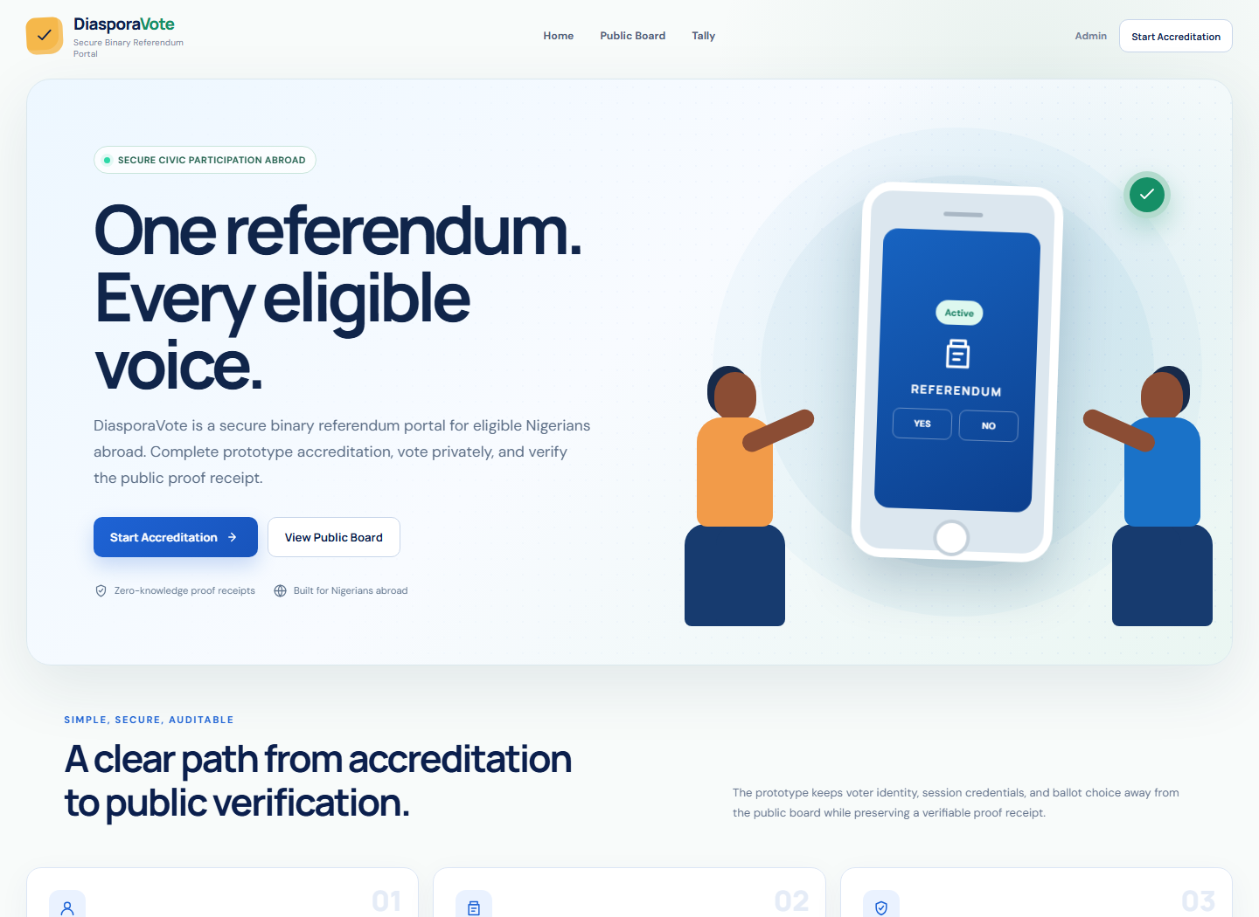
Figure 4.1: Landing page of the DiasporaVote prototype
Figure 4.2: Mock NIN accreditation page is presented below.
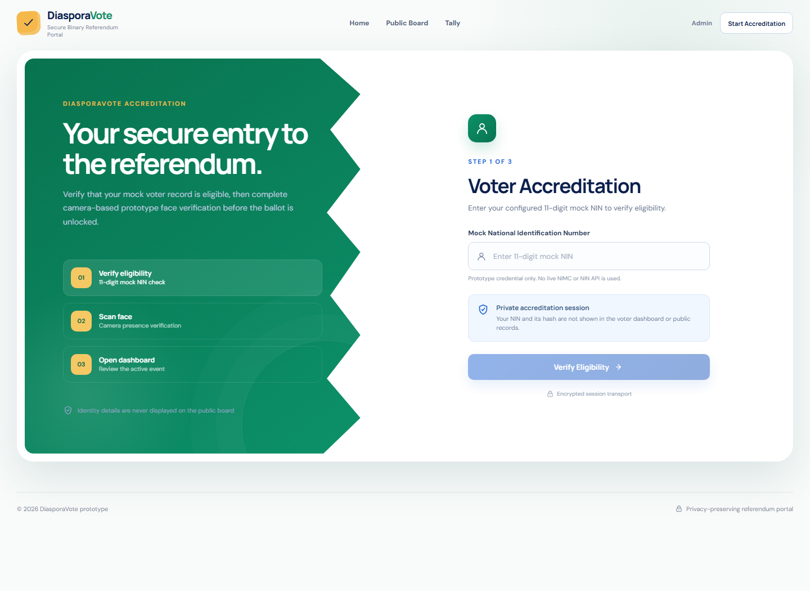
Figure 4.2: Mock NIN accreditation page
Figure 4.3: Camera-based prototype verification page is presented below.
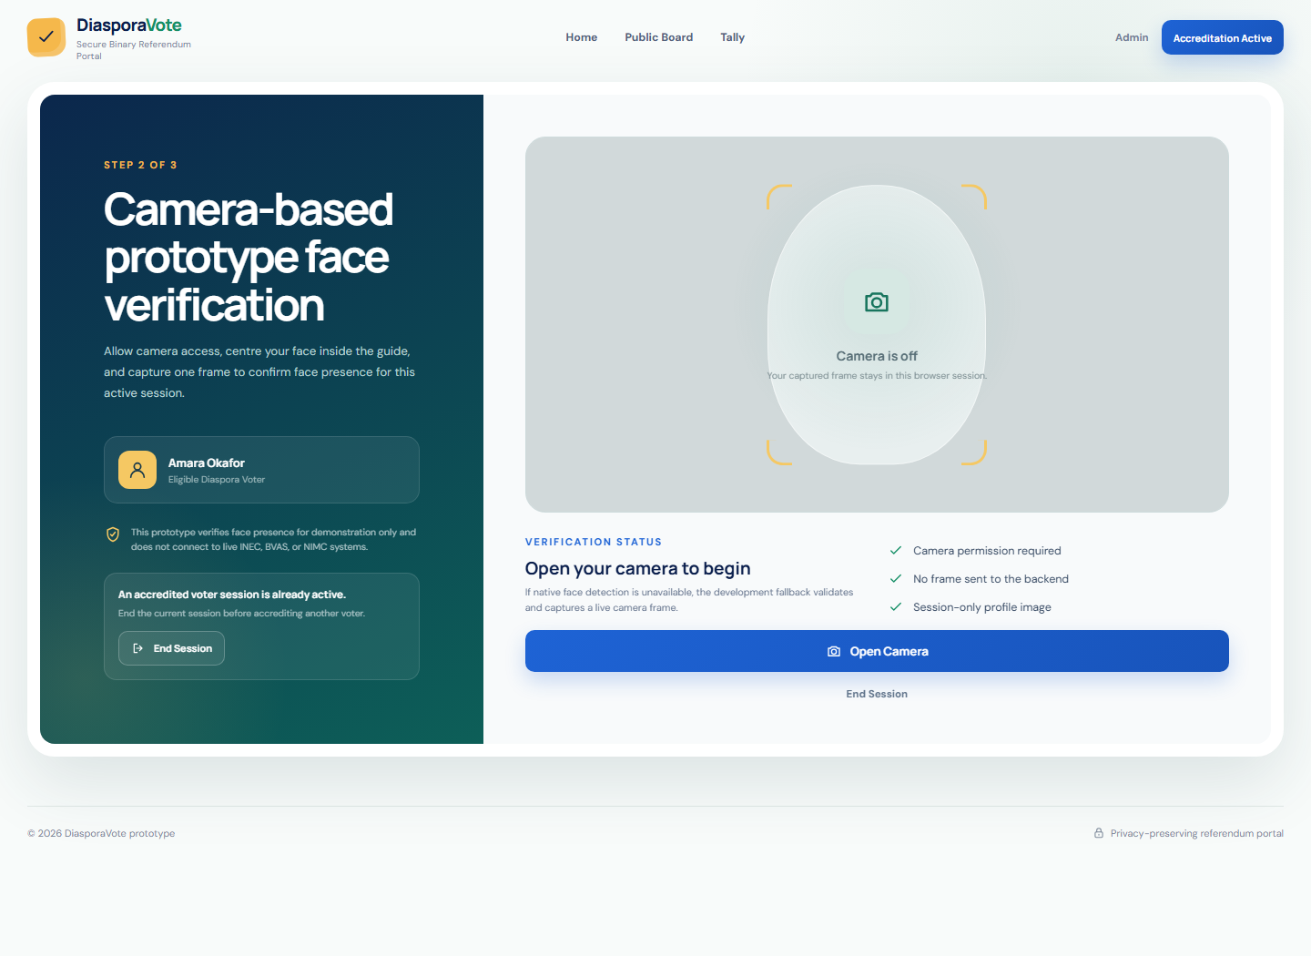
Figure 4.3: Camera-based prototype verification page
Figure 4.4: Event dashboard showing the active referendum is presented below.
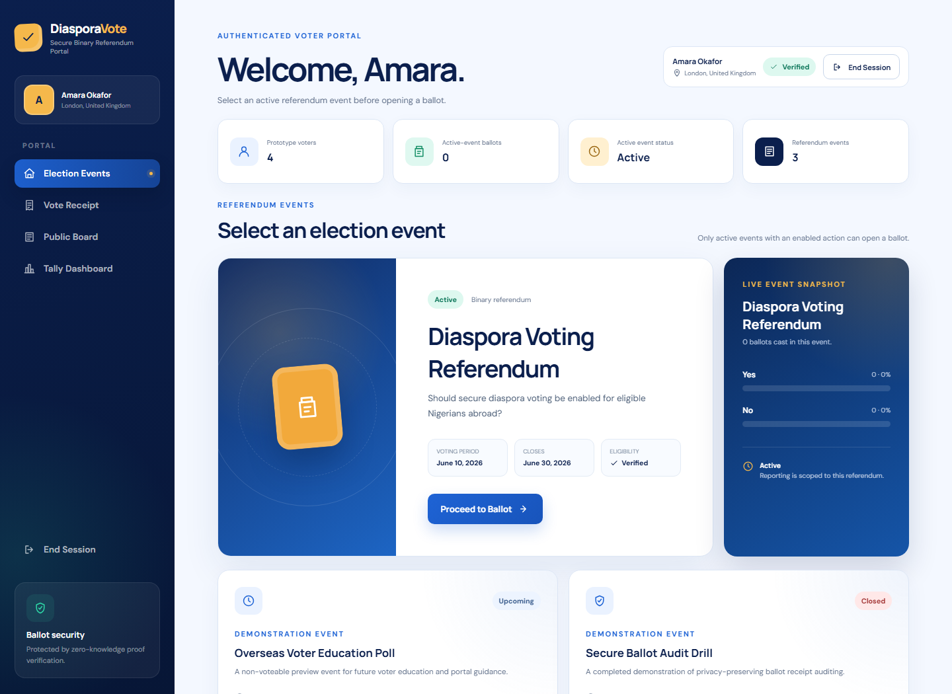
Figure 4.4: Event dashboard showing the active referendum
Figure 4.5: Active referendum ballot page is presented below.
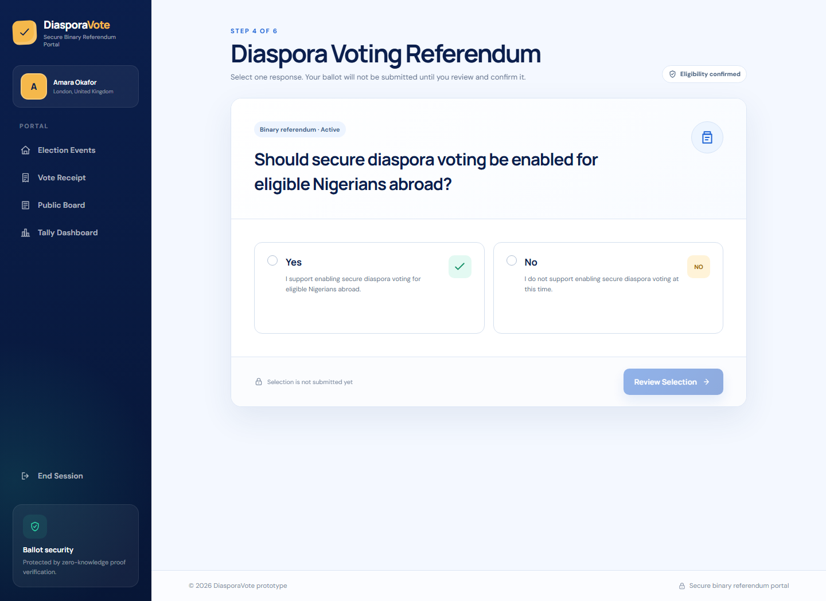
Figure 4.5: Active referendum ballot page
Figure 4.6: Vote review page is presented below.
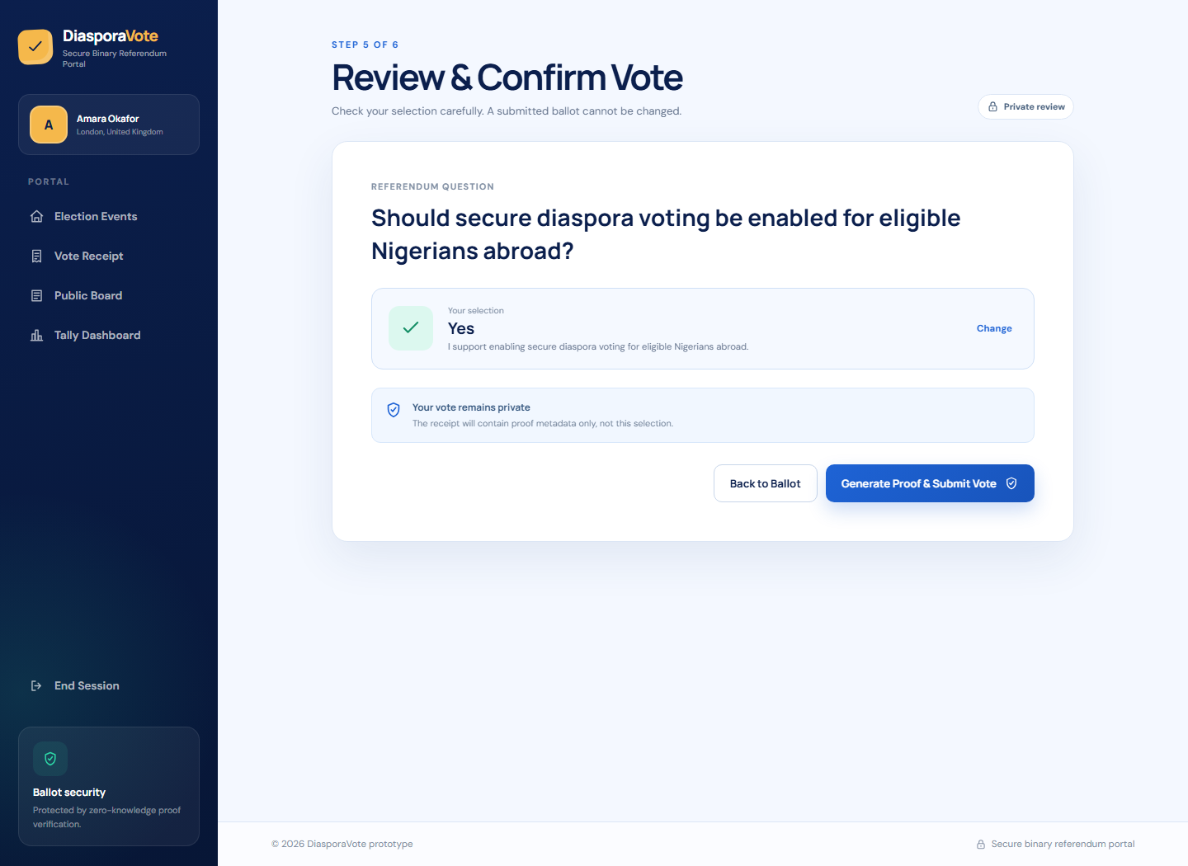
Figure 4.6: Vote review page
Figure 4.7: Receipt page showing the Ballot ID and Proof Hash is presented below.
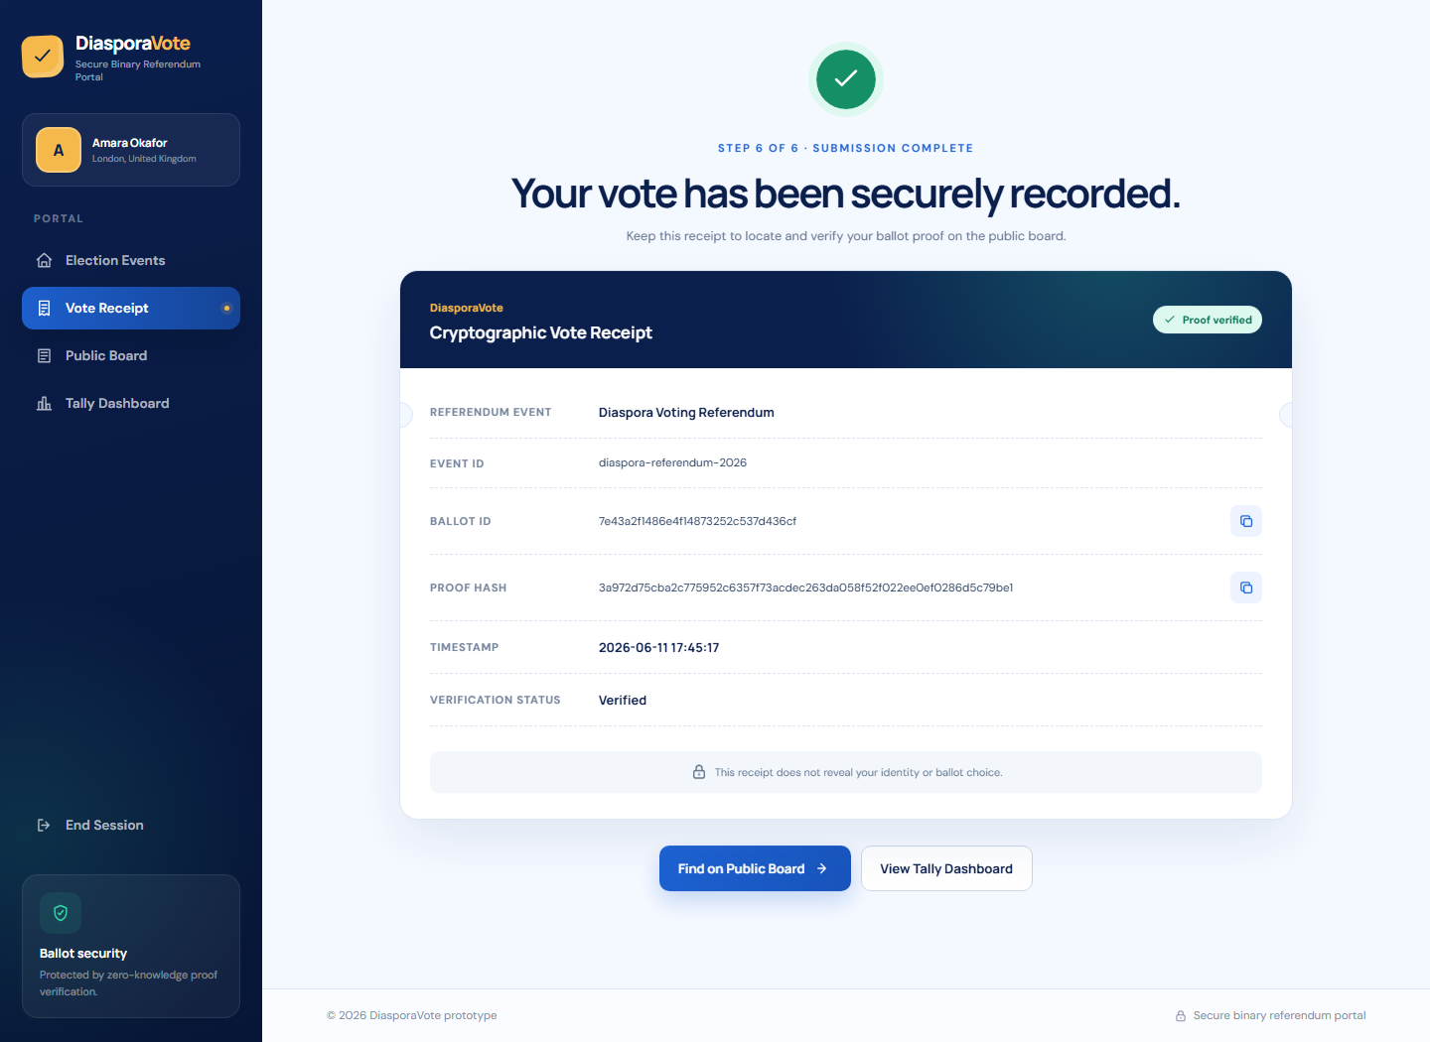
Figure 4.7: Receipt page showing the Ballot ID and Proof Hash
Figure 4.8: Public verification board is presented below.
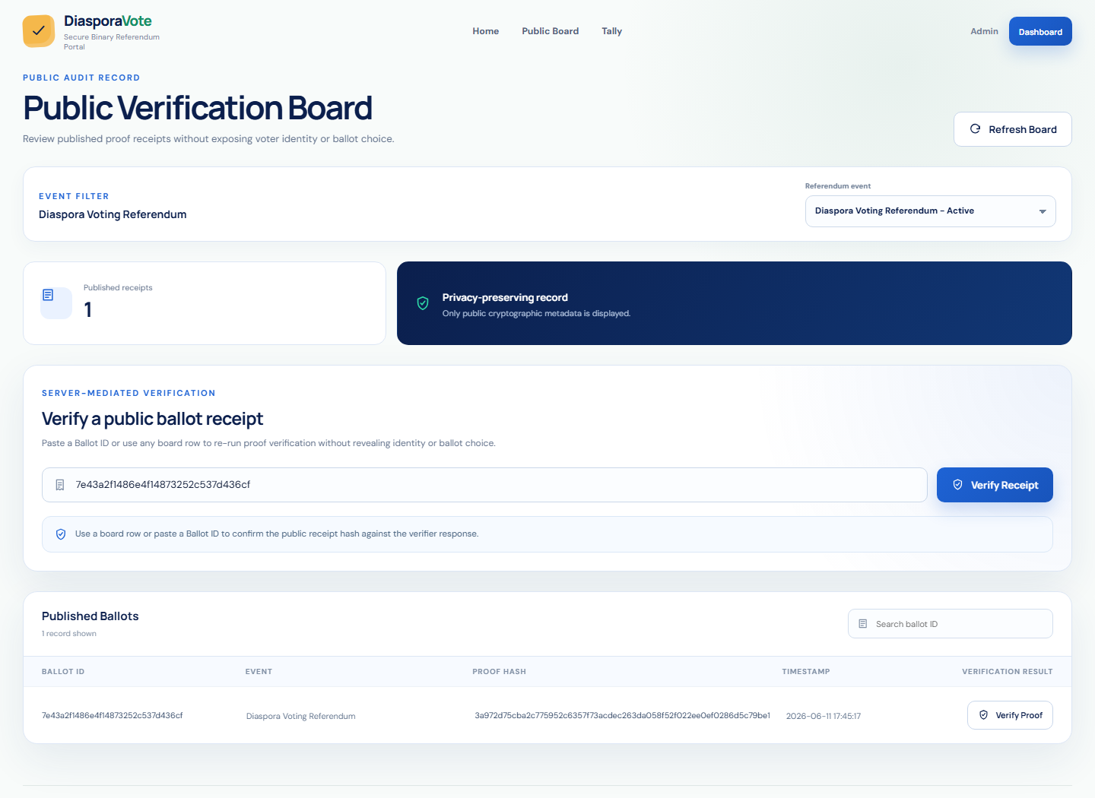
Figure 4.8: Public verification board
Figure 4.9: Proof verification result is presented below.
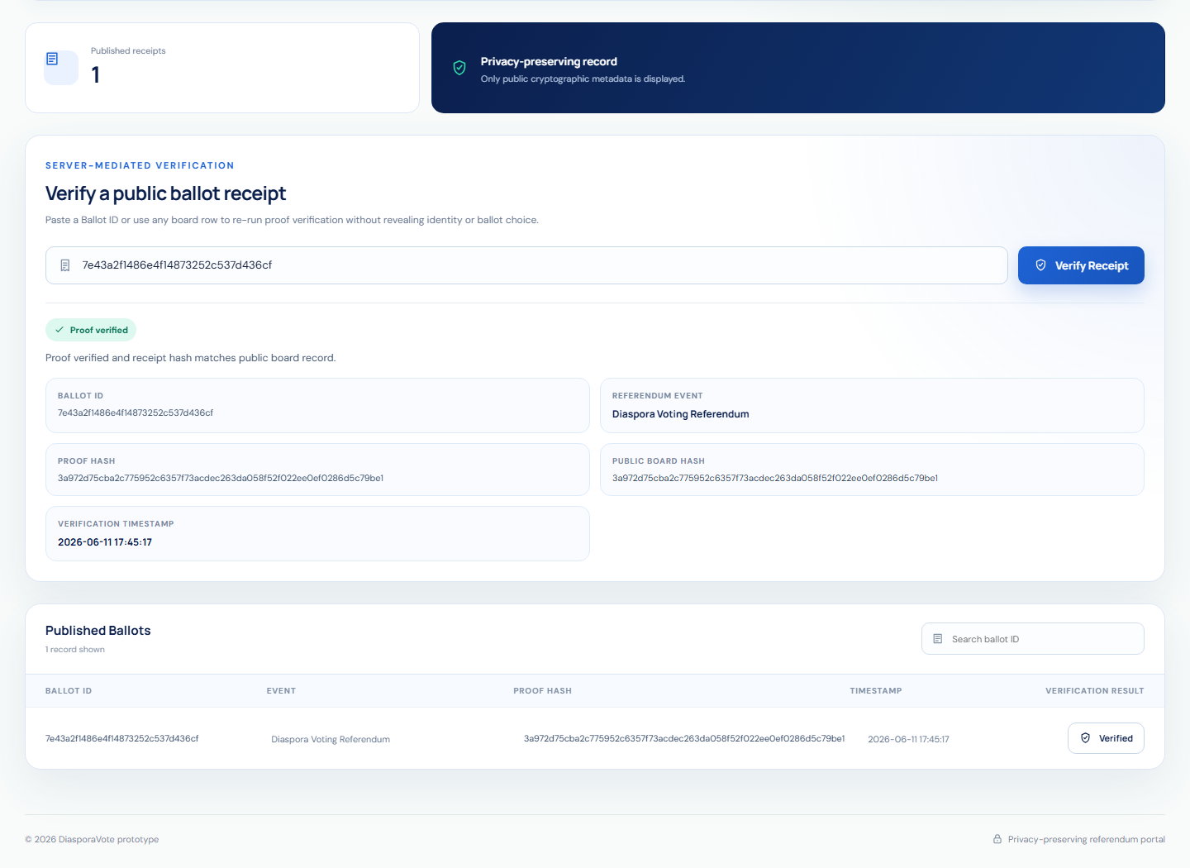
Figure 4.9: Proof verification result
Figure 4.10: Tally dashboard is presented below.
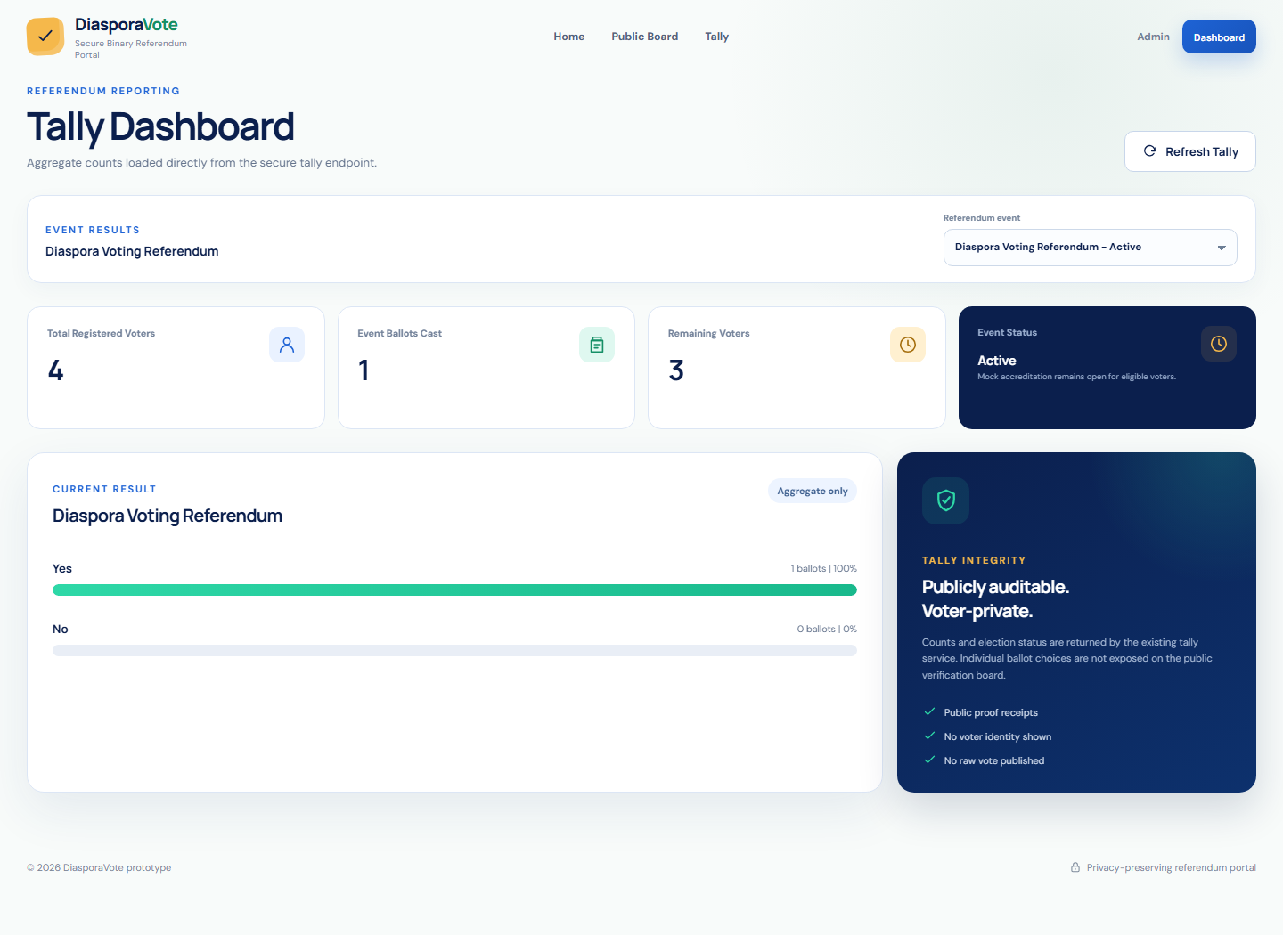
Figure 4.10: Tally dashboard
Figure 4.11: Admin login page is presented below.
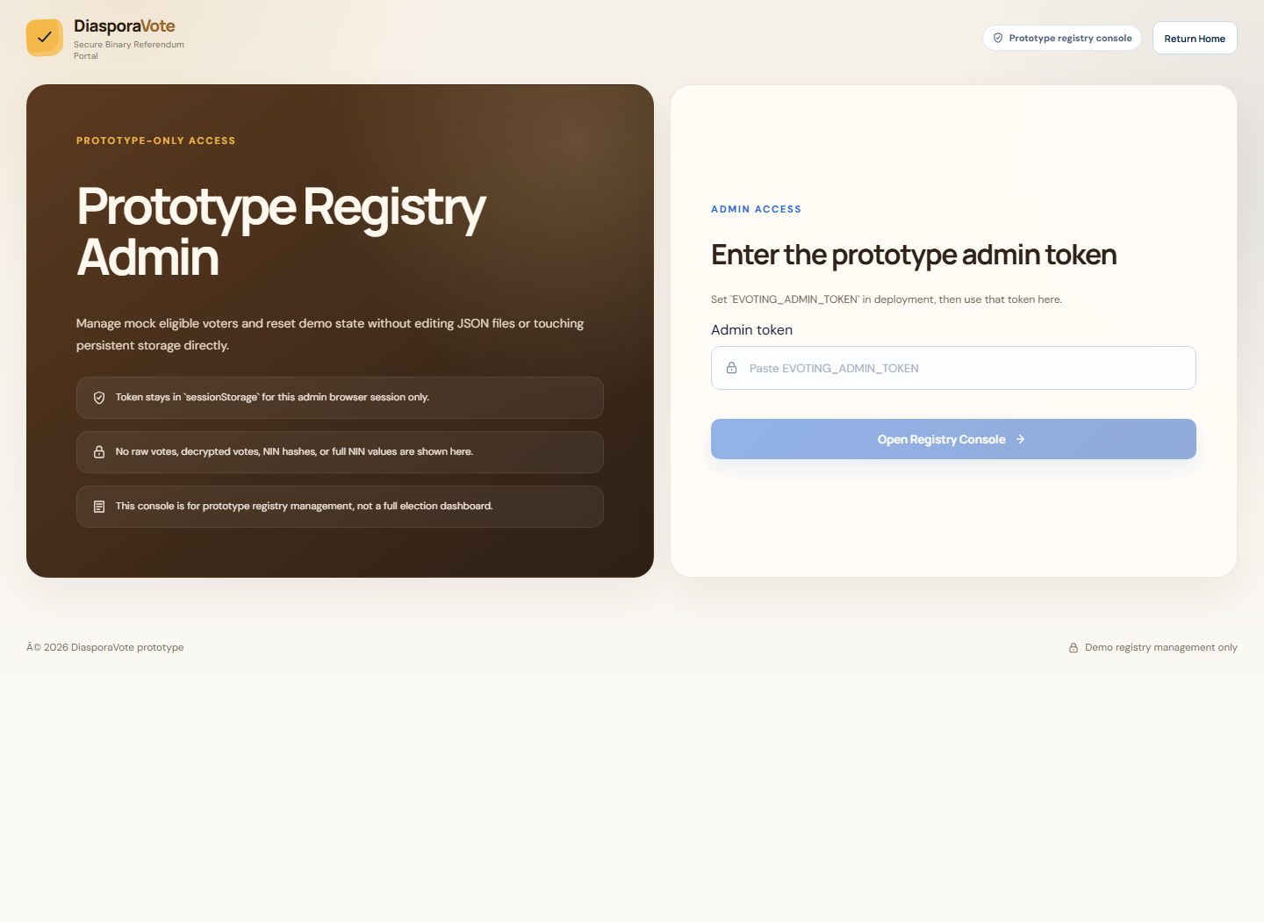
Figure 4.11: Admin login page
Figure 4.12: Admin mock voter registry page is presented below.
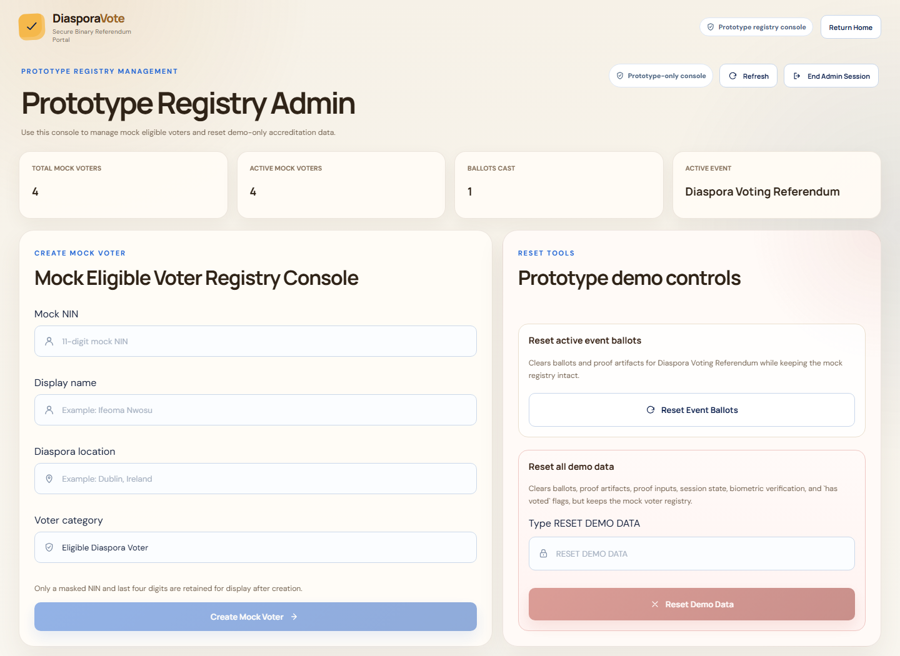
Figure 4.12: Admin mock voter registry page
Figure 4.13: Admin create-voter confirmation page is presented below.
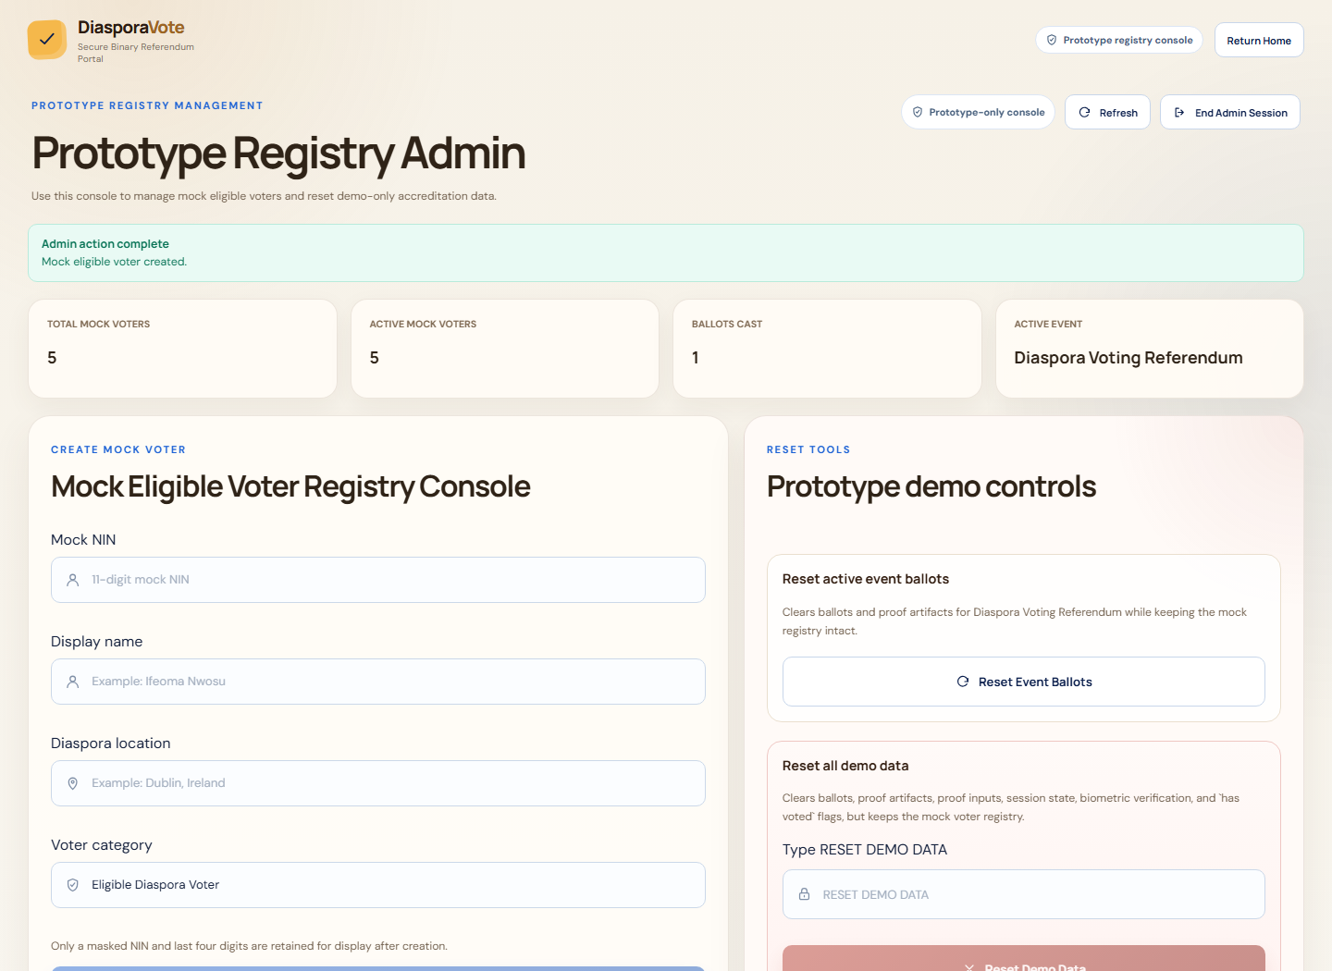
Figure 4.13: Admin create-voter confirmation page
The system was divided into modules to make implementation, testing, and explanation easier. Each module performed a specific function within the voting workflow. The major modules were the voter accreditation module, camera-based verification module, event module, ballot module, proof module, public verification module, tally module, admin module, and persistence module.
The voter accreditation module handled mock NIN submission and registry checking. The voter entered a mock NIN, and the backend checked whether the normalised value existed in the controlled registry. If the voter record was found and active, the system created a session and allowed the voter to continue. If the voter record was not found or inactive, the system rejected the attempt. This module represented the eligibility-checking part of the voting workflow.
The camera-based verification module handled prototype presence verification. After accreditation, the voter was required to complete a camera-based step before ballot access. This step was not implemented as certified facial recognition or BVAS-style identity matching. It was a prototype verification ceremony used to strengthen the voting workflow. The backend required this verification state before allowing vote submission.
The event module handled voting-event display and selection. The active event used in the prototype was the Diaspora Voting Referendum, with a binary ballot question asking whether secure diaspora voting should be enabled for eligible Nigerians abroad. The system also supported other demonstration events for interface realism, but the active referendum was the main event used for the project workflow. Event awareness ensured that ballots and tally results were linked to a specific referendum.
The ballot module handled vote selection, review, and submission. The voter could select either Yes or No and review the selected option before submitting. The backend validated the submitted ballot value and rejected unsupported options. This module ensured that the frontend voting interface matched the binary referendum design used in the proof workflow.
The proof module handled zk-STARK proof generation, proof verification, proof hashing, and proof-linked ballot acceptance. During vote submission, the backend invoked the Winterfell proof engine and verified the generated proof before storing the ballot. After successful verification, the backend computed a proof hash and linked it to the accepted ballot record. This module was central to the project because it implemented proof-backed acceptance.
The public verification module handled receipt checking and proof verification feedback. After a successful vote, the voter received a Ballot ID and Proof Hash. The public board displayed safe metadata that allowed the voter to confirm ballot inclusion without revealing voter identity or vote choice. The verification function allowed the backend to re-run proof verification for stored ballot records. This provided server-mediated public verification within the prototype.
The tally module handled aggregate result display. It counted accepted Yes and No ballots for the active referendum and displayed the total ballots cast. The tally was derived from stored ballot records rather than manually entered results. This ensured that the displayed count reflected accepted ballots within the controlled database.
The admin module handled mock registry management. Through the admin console, an authorised prototype administrator could create, view, deactivate, delete, and reset mock voter records. The admin module also supported demonstration reset operations. It did not allow the administrator to publicly expose voter ballot choices or alter proof hashes as public election results. This kept admin functions separate from voter-facing verification.
The persistence module supported record retention across deployment changes. The backend was configured with persistent storage so that registry and ballot data were not lost after redeployment. This was important for demonstrating that accepted ballots and proof verification records remained available after system updates. Persistence testing confirmed that stored ballot records remained accessible after redeployment.
The major user-facing interfaces of the system are summarised in Table 4.6.
Table 4.6: Program Interfaces
S/N | Interface | Description
1 | Landing page | Introduces the DiasporaVote prototype and directs users into the voting workflow.
2 | Accreditation page | Allows a mock voter to submit a mock NIN for registry checking.
3 | Camera verification page | Allows the voter to complete the prototype presence-verification step.
4 | Event dashboard | Displays the active referendum and available demonstration events.
5 | Ballot page | Allows the voter to select Yes or No for the active referendum.
6 | Review page | Allows the voter to confirm the selected choice before final submission.
7 | Receipt page | Displays the Ballot ID and Proof Hash after successful ballot acceptance.
8 | Public verification board | Displays privacy-preserving receipt metadata for accepted ballots.
9 | Tally dashboard | Displays aggregate Yes and No results for the active referendum.
10 | Admin console | Allows authorised management of mock voters and demonstration reset operations.

Overall, the implemented modules and interfaces worked together to support the project’s main objective. The voter-facing flow demonstrated accreditation, verification, voting, receipt checking, and tally viewing. The backend modules enforced the security and validation rules. The proof module added zk-STARK proof-backed acceptance. The database supported persistent record storage, and the public board provided a transparency layer without exposing sensitive voter or ballot information. This completed the implemented secure diaspora e-voting prototype within the controlled binary referendum scope.

CHAPTER FIVE: SUMMARY, RECOMMENDATIONS, LIMITATIONS, AND CONCLUSION

5.1 Summary
This study implemented a secure diaspora e-voting prototype for a controlled binary referendum using zk-STARK protocols. The completed system combined mock voter accreditation, camera-based prototype verification, event-aware ballot handling, proof-backed vote acceptance, encrypted storage, public receipt publication, server-mediated verification, and tally display within a single workflow designed for academic demonstration.
The project also showed that the trust problem in remote voting is broader than interface design alone. Registry checks, duplicate-vote control, proof generation, proof hashing, privacy-preserving public verification metadata, and aggregate tally logic all had to operate together before the prototype could make a credible security claim.

5.2 Recommendations
1. Independent client-side or auditor-side proof verification should be added so that verification does not depend entirely on the election server.
2. Stronger identity assurance should be explored only under proper institutional, legal, and privacy approval.
3. The proof workflow and surrounding backend logic should undergo a formal cryptographic and security audit.
4. Larger-scale performance testing should be carried out with higher ballot volumes and concurrent users.
5. Future work should address coercion resistance, usability evaluation, and broader public-audit models.

5.3 Limitations of the Study
1. The identity layer used a mock NIN registry and did not connect to national identity infrastructure.
2. The system did not integrate with official electoral infrastructure or any official national election backend.
3. The camera-based verification step was a prototype presence check and not certified biometric identity matching.
4. Public verification was server-mediated and did not yet provide fully independent local verification.
5. The ballot model was restricted to a controlled binary referendum.
6. The prototype was not production-ready for national elections.

5.4 Conclusion
The study achieved its main aim of designing and implementing a secure diaspora e-voting prototype using zk-STARK protocols. Within the limits of a final year technical project, the implemented system demonstrated that proof-backed ballot acceptance, controlled accreditation, privacy-preserving public verification metadata, and event-aware tallying can be combined into a coherent remote-voting workflow. The strongest conclusion of the work is therefore not that national diaspora voting has been solved, but that a careful, scope-controlled prototype can make the security and verification problem more concrete, measurable, and academically defensible for future research and development.

REFERENCES
Adida, B. (2008). Helios: Web-based open-audit voting. In Proceedings of the 17th USENIX Security Symposium (pp. 335-348).
Ali, S. T., & Murray, J. (2016). An overview of end-to-end verifiable voting systems. arXiv. https://arxiv.org/abs/1605.08554
Alsadi, M., Casey, M., Dragan, C. C., Dupressoir, F., Riley, L., Sallal, M., Schneider, S., Treharne, H., Wadsworth, J., & Wright, P. (2019). Towards end-to-end verifiable online voting: Adding verifiability to established voting systems. arXiv. https://arxiv.org/abs/1912.00288
Ben-Sasson, E., Bentov, I., Horesh, Y., & Riabzev, M. (2018). Scalable, transparent, and post-quantum secure computational integrity. IACR ePrint Archive, 2018/046. https://eprint.iacr.org/2018/046
Chondros, N., Zachariadis, A., Zhang, B., & Asonitou, D. (2015). D-DEMOS: A distributed, end-to-end verifiable, internet voting system. arXiv. https://arxiv.org/abs/1511.07098
Federal Republic of Nigeria. (2022). Electoral Act, 2022. Government Printer.
Goldwasser, S., Micali, S., & Rackoff, C. (1989). The knowledge complexity of interactive proof systems. SIAM Journal on Computing, 18(1), 186-208.
International IDEA. (2007). Voting from abroad: The International IDEA handbook. International Institute for Democracy and Electoral Assistance.
McMurtry, J., Carback, R., Chaum, D., Essex, A., & Popoveniuc, S. (2021). A practical, voter-verifiable method for demonstrating the integrity of election outcomes using standard voting equipment. arXiv. https://arxiv.org/abs/2105.09141
Quaglia, E. A., & Smyth, B. (2017). A short introduction to secrecy and verifiability for elections. arXiv. https://arxiv.org/abs/1702.03168
The Belenios voting system. (n.d.). https://www.belenios.org/

